Testing Exercise Report

executed by

**Team Lily**

consisting of:

1. … Ad-hoc testing
2. … Exploratory testing: team For Dogs
3. … Exploratory testing: team Search and Basket
4. … Exploratory Testing: team For Cats
5. … Structured testing: Script writer
6. … Exploratory testing: team Search and Basket
7. … Exploratory testing: team Lilyland; Report Editor
8. Irena Varbanova, iivarbanova@gmail.com, Exploratory testing: team For Cats, Exploratory testing: team For Dogs
9. … Structured testing: Script execution
10. … Structured testing: Script execution, Exploratory testing: team Lilyland

Table of Contents

1. Partial Test Plan 4

***Overview:*** 4

***Methods:*** 5

2. Exploratory Testing Log & Report 11

**Charter:** Explore cats 11

**Charter:** Explore dogs 13

**Charter:** Shop info 15

**Charter:** Search, Basket 17

3. Issues Found and Reported 23

● Major Severity 23

● Normal Severity 42

∙ Minor Severity 63

# Partial Test Plan

## ***Overview:***

Things to test:

This partial test plan covers: the test scenario for browsing the website, adding an item to the shopping cart, checking out stopping right before the PayPal Log-In/card selection. A full coverage test scenario for the PET CARE section is also performed. A negative test scenario for a non-successful newsletter sign-up. A negative test scenario for purchasing an out-of-stock item.

Things NOT to test:

Do not perform: performance test, stress test, security tests and other tests that have the potential to sabotage the working LIVE product.

Due date:

The report must be finalized and turned-in by 23:59 28.06.2021

## ***Methods:***

The standard end-to-end scenario must be tested using the “Happy path” method following the scenario:

Name: End-to-end scenario: Successful purchase of a product

Objective: To verify that the user is able to navigate the site, add items to the basket and be able to checkout

Priority: High

Browsers: Google Chrome, Microsoft Edge, Opera, Safari (iOS)

Dates Created on: 06/24/2021 by …

Updated on: 06/24/2021 by …

**Test Script:**

Steps:

1: Open https://www.lilyskitchen.co.uk

Expected Result: The site loads successfully

2: Navigate to the "**For Cats**" icon located on top of the page, next to the site logo

Expected Result: A drop-down menu appears

3: Select **category** and click on it

Test data: Kitten category

Expected Result: New page with the selected category loads successfully

4 Step: Choose an option from the **Ingredients** options located on the left side of the page

Test data: Chicken

Expected Result: The page with the selected option loads successfully

5 Step: Scroll down to the bottom of the page and **select** the last product available in stock

Test data: Chicken & White Fish Kitten Dry Food

Expected Result: The page of the selected item loads successfully

6 Step: Click on the pictures available for the selected item

Expected Result: The pictures are clear and visible

7 Step: Scroll down the page, navigate to the product options below "Price" and select an option for **Pack Size**

Test data: 350

Expected Result: The field displays the desired pack size

8 Step: Click on the plus/minus button to choose **Quantity**

Test data: 1

Expected Result: The selection is registered

9 Step: Choose an option for **Purchase Frequency**

Test data: one-time purchase

Expected Result: The selection is registered

10 Step: Click on the **Add To Basket** button located below the purchase frequency field

Expected Result: The item is added to the basket; a sub menu appears in the top right corner of the page

11 Step: Click on the **Basket menu** located in the top right corner of the page

Expected Result: The page with the customer's basket loads successfully

12 Step: Click on **Checkout** located on the right side of the page, below the order subtotal price

Expected Result: The page with the account for checkout loads successfully

13 Step: On the right side of the page, enter data for checkout as a guest

Test data: e-mail address: lily.team@abv.bg

Expected Result: The field accepts entered data; Delivery page loads

14 Step: Enter valid data for **delivery**

Test data:

*First name: Lily*

*Last name: Team*

*Phone number: 00359888888888*

*Address: Shakespeare's Globe*

Expected Result: The field accepts entered data and the address is auto filled

15 Step: Check the option for billing address

Expected Result: The option is selected automatically; change option is available and working

16 Step: Scroll down the page and choose delivery time

Test data: Sunday delivery

Expected Result: The option is marked as selected

17 Step: Click on "**Go To Billing**" on the bottom of the page

Expected Result: The page with billing information loads successfully

18 Step: Scroll to the **Payment Method** box and choose payment method

Test data: Debit/Credit card

Expected Result: The user is able to make a choice

**Test execution results:**

**Test passed!**

Broken links must be tested using brokenlinkcheck.com:

**Test execution results:**

**FAILED!** 3 broken links were discovered!

Name: Unsuccessful signup to Lily’s Kitchen’s newsletters using wrong email format

Objective: Field data type validation > To verify that the user is not able to signup providing in-valid input

Priority: Normal

Browsers: Google Chrome, Microsoft Edge, Opera, Safari (iOS)

Dates Created on: 06/26/2021 by …

Updated on: 06/26/2021 by …

**Test Script:**

Steps:

1. Open the URL of the site under test

Test data: https://www.lilyskitchen.co.uk

Expected result: The site loads successfully

2. Scroll down to the “Stay In Touch” box and click on the data field

Expected result: The user is able to navigate to the “Stay in Touch” box and click on the empty data field

3. Enter invalid input data for e-mail address

Test data: lily@abv

Expected result: The field accepts entered data

4. Click on the “Go” button right after the input field

Expected result: The signup fails, the user is notified with error message that the email ad-dress is incorrect

**Test execution results:**

**Test passed!**

Attachments:

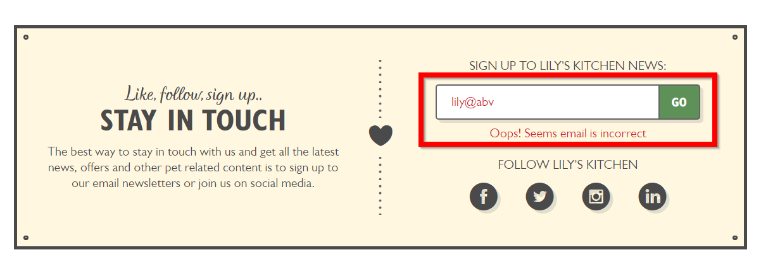

Name: Unsuccessful purchase of an item out of stock

Objective: To verify that the user is not able to add a product which appears to be out of stock

Priority: Normal

Browsers: Google Chrome, Microsoft Edge, Opera, Safari (iOS)

Dates Created on: 06/26/2021 by …

Updated on: 06/26/2021 by …

**Test Script:**

Steps:

1. Open the URL of the site under test - https://www.lilyskitchen.co.uk

Expected result: The site loads successfully

2. Navigate to the **“For Cats”** sign left of the main logo and from the drop-down menu choose “Kitten” submenu from “Shop by Age” left column

Expected result: The “Kitten Food” page loads successfully

3. Scroll down the page and navigate to the last item which appears to be out of stock

Expected result: The “Quick Buy” button is grayed out

4. Click on the “Quick Buy” button below the item

Expected result: The user is not able to click on the button

**Test execution results:**

**Test passed!**

# Exploratory Testing Log & Report

## **Charter:** Explore cats

**Areas:** Cat product related pages

**Test Environment URL:** https://www.lilyskitchen.co.uk/

**Test Username:** Unregistered User

**Start:** 14:10

**Testers:** Irena Varbanova (Navigator) and …(Operator)

**Duration:** 70 minutes

**End:** 15:20

**Date:** 26.06.2021

**Testing Techniques:** In this Charter are applied: *Pair-Based testing* (Operator and Navigator); *The Landmark Tour*; *Yellow hats*

*Testing Notes:*

14:10 Open the website <https://www.lilyskitchen.co.uk/>

14:11 Scroll down to the bottom of the Main Page, then go back to the top of the page, hover FOR CATS at the green top navigation menu

14:15 On the shown menu click the image on the right “SHOP CAT”, scroll down and in the left Filter menu in LIFESTAGE there is only 1 icon of a cat - there are 2 missing icons of a cat

14:19 Go back to the top of the Main Page, hover FOR CATS in the green navigation menu - there are visible 3 icons of a cat in Shop by AGE

14:24 Scroll down, in the left Filter menu click on FOOD FOR CATS, then click “+” at Shop by AGE - in LIFESTAGE there are 4 icons - 3 of them are cats and 1 of them is a dog

14:30 Click on the icon of the dog in the LIFESTAGE - there are 2 products for cats in the list, click on the product “Fish & Turkey Senior Dry Food'' - the product is for cats

14:35 Go back one step and click on the other product “Fish & Turkey Senior Dry Food (4 x 800g) - the product is for cats

14:38 Go back one step, unmark the icon of the dog, click on the cat’s icon “Senior (7+ years)” - there are 2 products, click on the left product, go back one step and click the other product, then go back one step

14:41 In FOOD FOR CATS click on “+” on Shop for SPECIAL DIET, then click on “Hypoallergenic”

14:42 Click on “Organic” in Shop for SPECIAL DIET - a pop-up image is shown

14:44 Click on “close” button at the pop-up image and click on “Organic” again - a pop-up image is shown again

14:47 Click on anything else of the page

14:48 Unmark cat’s icon “Senior” in LIFESTAGE

14:49 Click on the icon “Kitten” in LIFESTAGE and then unmark the icon, in Shop by AGE click on “Kitten”

14:51 In Shop for SPECIAL DIET click on “Grain free” and scroll down

14:54 Go back to the Shop for SPECIAL DIET, click “Organic” and scroll down

14:57 Go back to the Shop for SPECIAL DIET, click on “Hypoallergenic” and scroll down

15:02 Click on “Show All (46)” after the list with products at the bottom of the page

15:06 Go back to the top of the page, click on the drop-down button and choose “Newest” (at the right of the page), scroll down to the bottom of the page - the products are not shown in correct manner

15:13 Go back to the bottom of the page

15:15 Click on “Pork” in INGREDIENTS - at LIFESTAGE there are 3 icons of cats ordered incorrectly

15:20 Test ends

Charter Report:

Number of sessions completed: 1

Number of bugs found: 5

Time spent on session setup: 15 minutes

Time spent on testing: 70 minutes

Time spent on analyzing issues and problems: 4 hours

## **Charter:** Explore dogs

**Areas:** Dog product related pages

**Test Environment URL:** https://www.lilyskitchen.co.uk/

**Test Username:** Unregistered User

**Start:** 22:10

**Testers:** Irena Varbanova (Operator) and …(Observer)

**Duration:** 70 minutes

**End:** 23:20

**Date**: 26.06.2021

**Testing Techniques:** In this Charter are applied: *Pair-Based testing* (Operator and Observer); *The Antisocial Tour*; *Black hats*

*Testing Notes:*

22:10 Open the website <https://www.lilyskitchen.co.uk/>

22:11 Scroll down to the bottom of the Main Page, then go back to the top of the page, click on the green image “Menu FOR DOGS>>”

22:15 In the Filter menu click on FOOD FOR DOGS, then click “+” at Shop by AGE, choose and click on “Puppy” - there is an image on “Puppy” in LIFESTAGE

22:17 Go back to Shop by AGE and click on “Adult” - there are 2 images of а dog in LIFESTAGE - “Adult” and “Senior”

22:18 Go back to Shop by AGE and click on “Senior” - there are 2 images of dogs in LIFESTAGE - “Adult” and “Senior”

22:22 Go back to Shop by AGE and click on Puppy - there is 1 image of a dog in LIFESTAGE

22:23 Click on “Puppy” in LIFESTAGE, then go back to Shop by AGE and click on “Adult” - it appears a pop-up image

22:25 Click on the close button at the pop-up image and go back to Shop by AGE and click on “Senior” - the pop-up image appears again

22:27 Click on the close button at the pop-up image, then in Filter menu click “CLEAR ALL” - in Shop by AGE “Puppy” is still selected and in the LIFESTAGE there is an icon of “Puppy”

22:29 Scroll down to the bottom of the page and click on “Show all”, then go back to the drop-down button on the right at the top of the page, click on “BEST MATCHES” and go down to the page

22:32 Go back to the drop-down button and choose “NEWEST”, then scroll down to the bottom of the page - there are no product with label “NEW”

22:36 Go to the left Filter on the page and click “Adult” - it appears a pop-up image again

22:37 Click “CLEAR ALL”, then in Shop by AGE click on “Adult”, scroll down to the bottom of the page and click “Show all (133)”

22:39 Go back to the drop-down button and select “PRODUCT A - Z”, then go down

22:44 Go back to the drop-down button and select “NEWEST” - there are products with label “NEW” which are not arranged correctly according to the drop-down button

22:50 Click on “Senior” from Shop by AGE, then click on “PRODUCT A - Z” from drop down button at the right, scroll down and click on the second page

22:53 Scroll down and go back to top of the page, then select from the drop-down button “NEWEST” and go down to the list of products - the products with label “NEW” are not at the top of the list

22:57 Click on the third product from the list on first line “Organic Bedtime Biscuits”, go down to the Feeding Guidelines

22:58 Select “Your dog” and press the START button, then choose “Puppy 2-4 months”, press NEXT, enter dog’s weight “2” - the NEXT button looks inactive

23:04 Click on NEXT button - now it is active. Press NEXT once again and select “Dry”, then press NEXT and click on the product, press FINISH

23:08 Go back to the top of the page, hover the FOR DOGS image in the green top navigation menu, click “SHOW ALL RECIPES”

23:10 In the Filter on the left click on INGREDIENTS “Chicken” and on DIET “Chicken free”, go to the top - in Filter there are selected controversial options “Chicken” and “Chicken free”. The product in the list meets only one of the chosen filters

23:15 Click on “CLEAR ALL”, select on INGREDIENTS “Pork” and on DIET “Pork free”, go to the top - in Filter there are selected controversial options “Pork” and “Pork free”. The product in the list meets only one of the chosen filters

23:20 Test end

Charter Report:

Number of sessions completed: 1

Number of bugs found: 6

Time spent on session setup: 15 minutes

Time spent on testing: 70 minutes

Time spent on analyzing issues and problems: 5 hours

## **Charter:** Shop info

**Areas:** Lilyland info related pages

**Test Environment URL:** https://www.lilyskitchen.co.uk/lilyland/our-world/about-lilys-kitchen/our-story.html

**Test Username:** Unsigned user

**Start:** 25. Jun. 2021 14:00

**Duration:** 23 min

**End:** 25. Jun. 2021 14:23

**Testers:** … (operator) and … (observer)

*Testing Notes:*

Testing Techniques: Landmarks Tour, Pair testing (operator and observer)

14:00 Open https://www.lilyskitchen.co.uk

14:00 Choose the LILYLAND category

14:01 Play the embedded YouTube video

14:02 Open Certified Goodness

14:03 Open the report in BUSINESS AS A FORCE FOR GOOD

14:04 Close tab with report

14:05 Open WHAT IS PROPER FOOD FOR PETS?

14:06 Open WHAT’S IN OUR FOOD?

14:06 Return to previous page

14:07 Open FIND OUT MORE

14:07 Select Our values in ABOUT LILY’S KITCHEN in LILYLAND dropdown

14:08 Select Our charity work in ABOUT LILY’S KITCHEN in LILYLAND dropdown

14:09 Play embedded video

14:09 Select Subscription service in ABOUT LILY’S KITCHEN in LILYLAND dropdown

14:10 Select SHOP NOW in the *Menu FOR DOGS* banner

14:11 Return to Subscription service

14:11 Repeat for Menu FOR CATS

14:11 Return to Subscription service

14:12 Select every drop down paragraph in LILY'S KITCHEN SUBSCRIPTION SERVICE FAQS

14:13 All drop down paragraphs extend

14:14 Select How to recycle packaging in ABOUT LILY’S KITCHEN category

14:15 Open link to teracycle.com in under step 1 of TERRACYCLE

14:16 Return to How to recycle packaging

14:16 Select GET STARTED button at the end of TERRACYCLE section

14:16 Return to How to recycle packaging

14:17 Hover over LILYLAND icon and select News in ABOUT LILY’S KITCHEN category

14:18 Links in OUR PREVIOUS ANNOUNCEMENTS are not clearly visible as links and is unclear where they end

14:20 Selected Read Henrietta's note from April 16th 2020 in full here in OUR PREVIOUS ANNOUNCEMENTS

14:21 Select click here to download the full press release. on the first line in OUR PREVIOUS ANNOUNCEMENTS

14:22 Selected Read Lily's Kitchen announcement from April 1st 2020 in full here in OUR PREVIOUS ANNOUNCEMENTS

14:23 Select click here to download the full press release. on the second line in OUR PREVIOUS ANNOUNCEMENTS

14:23 All major landmarks in LILYLAND have been visited; end of session

Charter Report:

Number of sessions completed: 1

Number of bugs found: 1

Time spent on session setup: 5 minutes

Time spent on testing: 23 minutes

Time spent on analyzing issues and problems: 1 hour

## **Charter:** Search, Basket

**Areas:** Site search field and basket page

**Test:** Environment URL: https://www.lilyskitchen.co.uk/basket/ & https://www.lilyskitchen.co.uk/

**Test Username:** Unsigned user

**Start:** 16:27 Session 1

21:00 Session 2

**Testers:** … (Navigator, Observer), … (Operator, Observer)

**Duration:** 138 min Session 1

40 min Session 2

**End:** 18:45 Session 1;

21:40Session 2;

**Testing Techniques:** Pair testing (operator and observer, navigator and operator); Yellow hat, Couch Potato Tour, Landmark tour

*Testing Notes:*

Session 1:

Date: 24.06.2021

16:25 Open https://www.lilyskitchen.co.uk/, click on Search icon

16:25 Initiate searching for strings that are probable for the user to be interested in but are with typing mistake. Search for string “LILI” /Note: The correct spelling is LILY/

16:25 Search returns results: 218 Products, 60 Articles

16:25 Open random product of the results (Compostable Bags) and check if in the name of the item or in the description is match for “LILI”.

16:25 Ctrl + F LILI = Phrase not found

16:25 Open random product of the results (we clicked on Extra Large Dry Food Bag Clip) and check if in the name of the item or in the description is match for “LILI”

16:26 Ctrl + F LILI = Phrase not found

16:27 Go back to the search results for LILI, the page 1 with the results

16:28 Open the product Extra Large Dry Food Bag Clip and scroll down.

16:28 Click on VIEW COMPOSITION BUTTON (under the COMPOSITION ribbon flag) for two products that are non-food.

16:28 Opens Composition tab but there is no data. Empty field.

16:28 Open the results page, click on the found articles (60 Articles) and scroll down the page.

16:28 Open random article (Clicked on What’s different about LILY’S KITCHEN pet food? / Read More.

16:28 Ctrl +F LILI = Phrase not found. Search for string “LILI” returns results where the string is not found.

16:29 Click main Search icon from the main page URL

16:29 Initiate sequence search - enter one letter only (small letter) for every letter in alphabet.

16:29 Search returns message: “Sorry, we couldn’t find any matching results for: a”

Same result is for all, except for the below, where happens following:

16:30 For letter “k” Search returns 24 results. No “k” in the item name /Salmon Dry Food, Lamb Dry Food/+

16:30 For letter “e” Search returns 4 results. Bug suspected.

16:31 For letter “n” Search returns 3 results. No “n” in the item name.

16:31 For letter “p” Search returns 1 results. No “p” in the item name.

16:32 Initiate sequence of manual search in the same manner for entry of a single capital letter for EN language.

16:32 For letter “E” Search returns 4 results. No “E” in the item name. /Salmon Treats (10x60g), Salmon Treats, Chicken Treats, Chicken Treats (10x60g)

16:32 For letter “G” Search returns 158 results. Many of the results don’t have “G” in the name. Suspected bug.

16:32 For letter “K” Search returns 24 results. No “K” in the item name.

16:32 For letter “N” Search returns 3 results. No “N” in the item name.

16:32 For letter “P” Search returns 1 results. No “P” in the item name.

16:32 Initiate Search with more than one letters – with two. Search by a part of a word (we did for “re” – part of “recipe”). No return result – doesn’t find anything.

16:32 Repeat same search from above line with added * (re*).

16:32 Search with partial word and an * in a string returns result.

16:33 Go to Search and insert “CHICKEN”. Try different selections for sorting – BY MOST POPULAR/BY BEST MATCHES.

16:33 Results from Sorting “By review” looks suspicious for bug: no adequacy of sorting by number of reviews; no adequacy of sorting by review stars. Not clear or understandable for user this choice of sorting criteria logic.

16:33 Select to view on one page all results – they do.

16:33 Same repeated for Articles – results don’t appear on one page but on two. (10 Articles – 8 on page 1, 2 on page 2).

16:33 Search for Cyrillic word (пиле) symbols – Search returns message „Sorry, we couldn’t find any matching results for: пиле “.

16:36 Click on Basket and open https://www.lilyskitchen.co.uk/basket/.

16:36 Browse random products and insert a random item in the basket. (Organic Bedtime Biscuits)

16:36 Open Organic Bedtime Biscuits, select for Quantity 2, click on Add to Basket, Click on View Basket.

16:36 In label Order Totals (Subtotal) appears 5.50 GBP in the Cart Summary.

16:36 Enter maximum quantity in Organic Bedtime Biscuits by clicking in the middle the number 999 – maximum allowable length of string is 3 symbols.

16:36 The respective subtotal calculates money according to 999 x item’s cost but in the Subtotal appears only for 999.

16:36 Go to the Select value, quantity field and enter “ff” and press Enter.

16:36 Basket deletes previous entered quantity (the 999) and changes to value 1. Basket recalculates for 1 and deletes previous calculation.

16:36 Use the Search icon to find item Organic Bedtime Biscuits. Add to basket 999 of this item. Red message appears: “Sorry, only 999 …”

16:36 Click on Add to Basket button – adds. Items om basket: 999.

16:36 Click on Organic Bedtime Biscuits picture and enter “ff” in the Quantity field.

16:36 “ff” changes automatically to 1. No message to user to notify for the change.

16:38 Go to the main page, click on “FOR DOGS”, select PUPPIES, select item Trial Pack for Puppies 12.60 GBP, click on item to Open. Insert 77 as Quantity and click on Add to Basket.

16:39 Return to previous page. Select QUICK BUY of the same and insert -7 between the plus and minus. Check in Basket – removed 7 items.

16:40 Return to previous page.

16:40 Select QUICK BUY of the same packaged item and enter 199. DO NOT CLICK ON THEM. Hold down Enter key. Quantity starts reducing. Suspected a bug but can be also a feature. The issue should be communicated with developers and Product Owner.

16:41 Initiate trials for different items if a user can add multiple times quantity 999. Test passed: 2 or 3 times adding of 999 items in the basket. Errors messages to user for not enough quantity appear.

16:41 Items can be added despite error for not enough quantity. Manifests for package-deal type product items (*Trial pack for puppies*).

16:44 Find promocodes for LILY’S KITCHEN with Google Search.

16:45 Add code LILYSWELCOME to Basket.

16:45 Misleading Message – Green tick mark and text for code not applied – all in green.

16:50 Add second time same code.

16:50 Produces a warning message for the user that code is already in the basket.

16:52 Add code PROPERWELCOME to Basket. One promocode neutralizes the other.

16:52 Green tick mark and text appear for code that is not applied.

16:55 Add 3rd promocode in the basket – result is the same. Bad user experience– 3 codes in green, with tick mark that look like applied, actually just one is taken into account for the calculation of the Subtotal.

17:22 Test behavior on different browsers – check for reproducibility of bugs - for single item or for a package deal item further. Selected random products from both FOR CATS and FOR DOGS.

18:03 Message for limitations related to Quantity in stock appears in the basket for the first time.

18:06 Wrong label for quantity appears in basket for products as part of a package. For same product only as a single item – message is IN STOCK. Manifests with larger values.

18:27 Go again to the Basket (click on basket icon). Click in the promocode entry field and insert extra-long string in the field.

18:30 Max length html attribute related error.

18:41 Click on Checkout

18:41 Test entries of different type values in the e-mail field:

A

a2

a@s

Appropriate warning messages appear.

Session 2:

Date: 27.06.2021

21:03 Open Search from the main URL

21:04 Test searching functionality for entering a combination string of one letter and a special character.

21:10 Result of Search for g^ returns 158 results.

21:15 Go to Search, click and start typing a real word. DO NOT click on enter. Dynamic recommendation engages and shows products.

21:16 Resize browser and automatically loads visualization of LILI’S KITCHEN main page thus making the search with dynamic result disappear. Very inconvenient for user.

Charter Report:

The number of sessions completed: 2

The number of bugs reported: 10

Time spent on session setup: 25minutes

Time spent on testing: ~7 hours

Time spent on analyzing issues or problems: ~7 hours

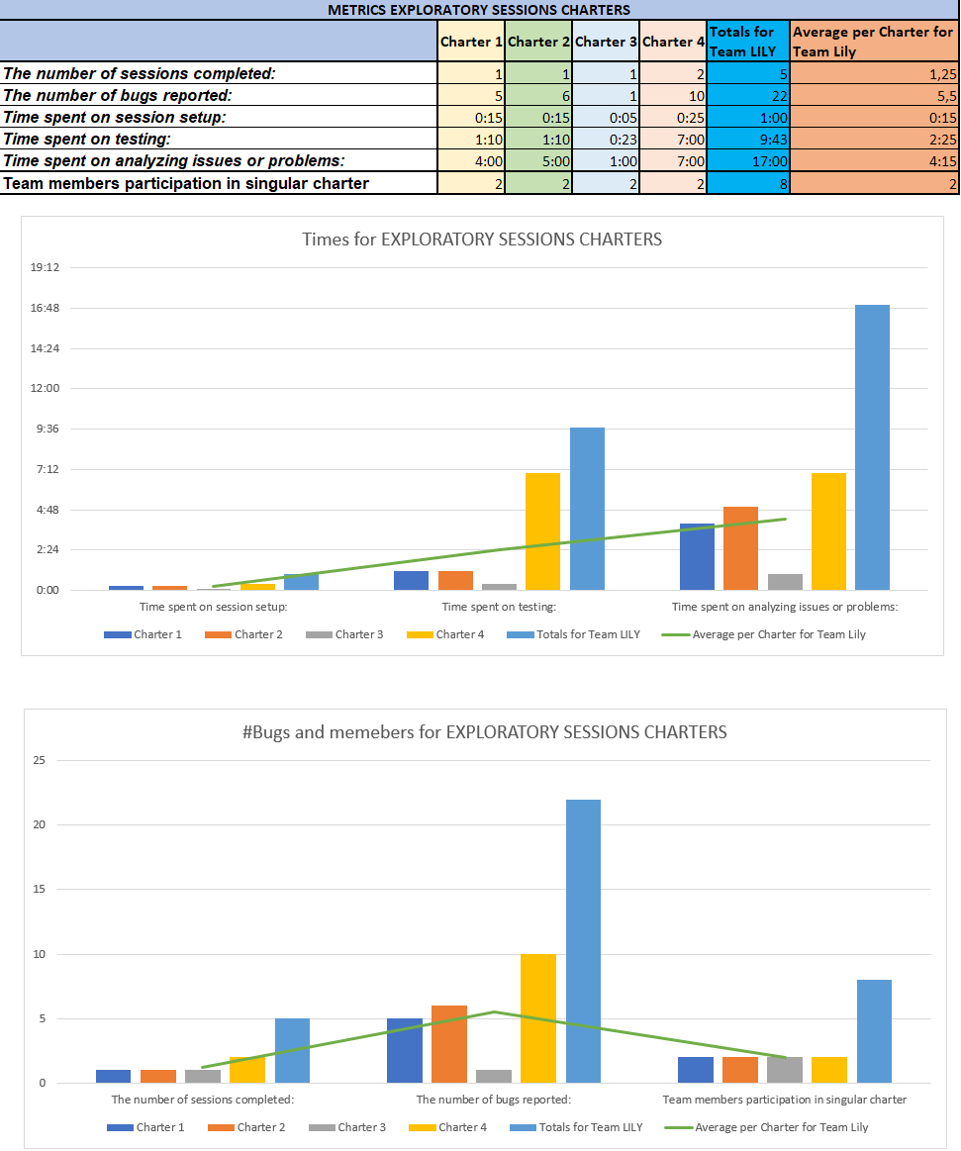

# Issues Found and Reported

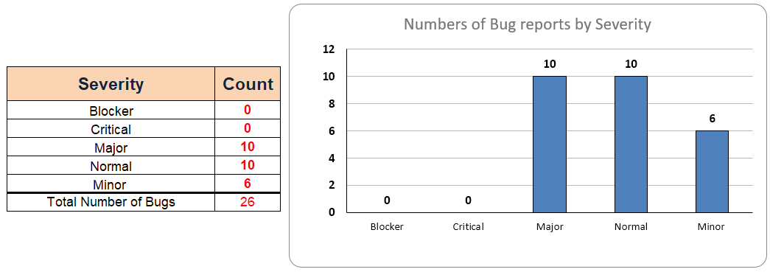

## Major Severity

### **Bug EE.1:** Broken internal link for "Shop Now" button under "Trial Pack for Dogs" at "Pet Care" menu

**Severity:** Major

**Environment:** Production

**Browser:** Google Chrome (**Reproducible on:** Microsoft Edge; Firefox; Opera)

**OS:** Windows 10

**Account:** Unsigned User

**Found by:** …, … and …

**Testing Methodology:** Discovered with brokenlinkcheck.com

**Date:** 26.06.2021

**Steps to reproduce:**

1. Open the site under test: [https://www.lilyskitchen.co.uk](https://www.lilyskitchen.co.uk/)
2. Click on the "Pet Care" menu on top right side of the site, next to the main logo
3. Choose "Feeding Your Dog" category
4. Scroll down to the bottom of the page and click on the "Shop Now" button

**Expected Result**: The linked page should load successfully and the page should be valid

**Actual Result**: The linked page loads successfully, but the page is not valid. "Page Not Found" out of sight notification appears on the left side of the page.

**Screenshots / Logs:**

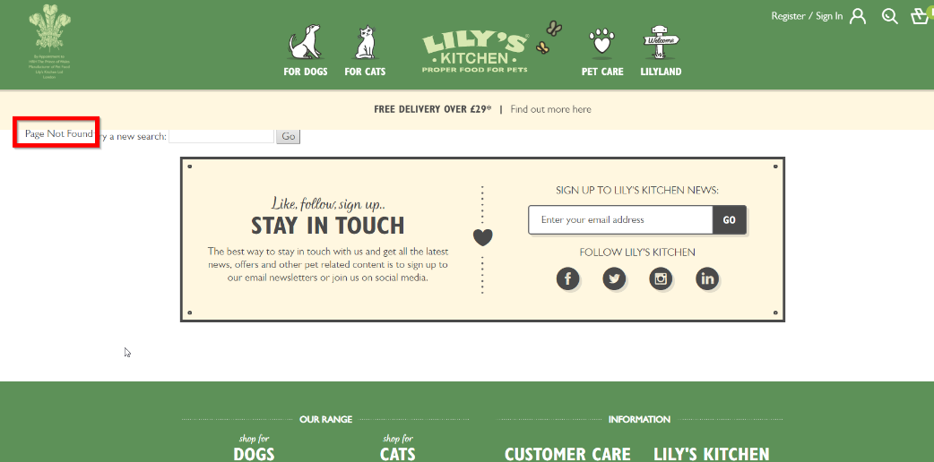

### **Bug EE.2:** Broken internal link for "Find It" video under "Hide & Treat" at "Pet Care" menu

**Severity:** Major

**Environment:** Production

**Browser:** Google Chrome (**Reproducible on:** all browsers and environments)

**Device:** Desktop

**OS:** Windows 10

**Account:** Unsigned User

**Found by:** …, … and …

**Testing Methodology:** Discovered with brokenlinkcheck.com

**Date:** 26.06.2021

**Steps to reproduce**:

1. Open the site under test: [https://www.lilyskitchen.co.uk](https://www.lilyskitchen.co.uk/)
2. Click on the "Pet Care" menu on top right side of the site, next to the main logo
3. Choose "Hide & Treat" category
4. Scroll down the page to “To keep your dog entertained” and click on the “Find it” internal link at point 3 of the bullet list.

**Expected Result**: The linked page should load successfully and the page should be valid

**Actual Result**: The page is not valid. "Page Not Found" notification appears.

**Screenshots / Logs:**

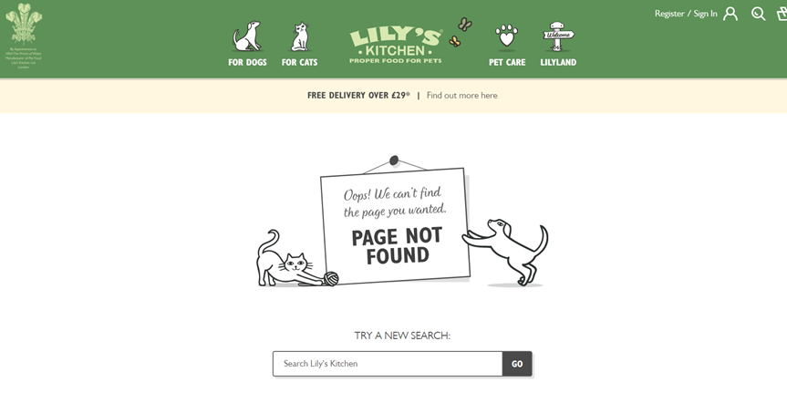

### **Bug EE.3:** Broken internal link for "Shop Now" button under "Gingerbread Trail" at "Pet Care" menu

**Severity:** Major

**Environment:** Production

**Browser:** Google Chrome (Reproducible on: all problems)

**Device:** Desktop

**OS:** Windows 10

**Account:** Unsigned User

**Found by:** …, … and …

**Testing Methodology:** Discovered with brokenlinkcheck.com

**Date:** 26.06.2021

**Steps to reproduce**:

1. Open the site under test: [https://www.lilyskitchen.co.uk](https://www.lilyskitchen.co.uk/)
2. Click on the "Pet Care" menu on top right side of the site, next to the main logo
3. Choose "Gingerbread Trail" category
4. Scroll down the page and click on the "Truly Naturals Mini Venison Sausages” internal link under the “You Will Need” sign.

**Expected Result**: The linked page should load successfully and the page should be valid

**Actual Result**: The linked page loads successfully, but the page is not valid. "Page Not Found" out of sight notification appears on the left side of the page.

**Screenshots / Logs:**

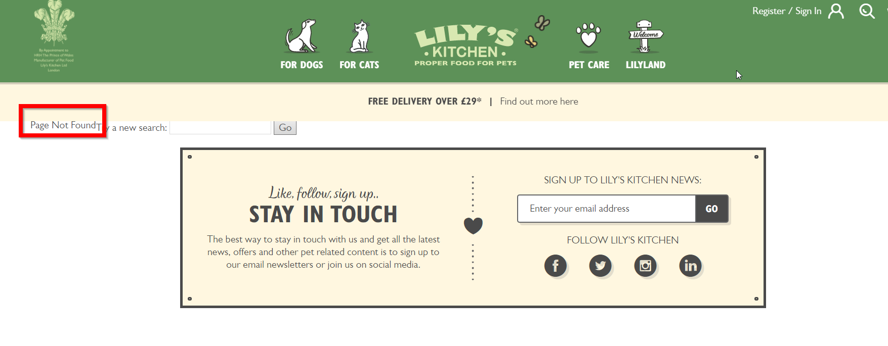

### **Bug 1.1:** A blank pop-up image appears

**Severity:** Major

**Environment:** Production

**Browser:** Firefox **(Reproducible on:** Google Chrome; Microsoft Edge; Opera)

**Device:** Desktop

**OS:** Windows 10 Pro

**Account:** Unregistered User

**Found by:** … and Irena Varbanova

**Testing Methodology:** Pair-Based Exploratory testing, Operator & Navigator

**Date:** 26.06.2021

**Steps to reproduce:**

1. Open the websitehttps://www.lilyskitchen.co.uk/
2. Hover FOR CATS at the green top navigation menu
3. Click on the right image below SHOP CAT
4. Scroll down
5. Click “+” at FOOD FOR CATS in the left Filter menu
6. Click “+” at Shop by AGE
7. Click on “Senior” in LIFESTAGE
8. In FOOD FOR CATS click “+” at Shop for SPECIAL DIET
9. Click on “Hypoallergenic”
10. Click on “Organic” in Shop for SPECIAL DIET

**Expected result:**

The User should select more than 1 option in left Filter menu

**Actual result:**

The User is restricted by choosing for more option in left Filter menu

**Screenshots / Logs:**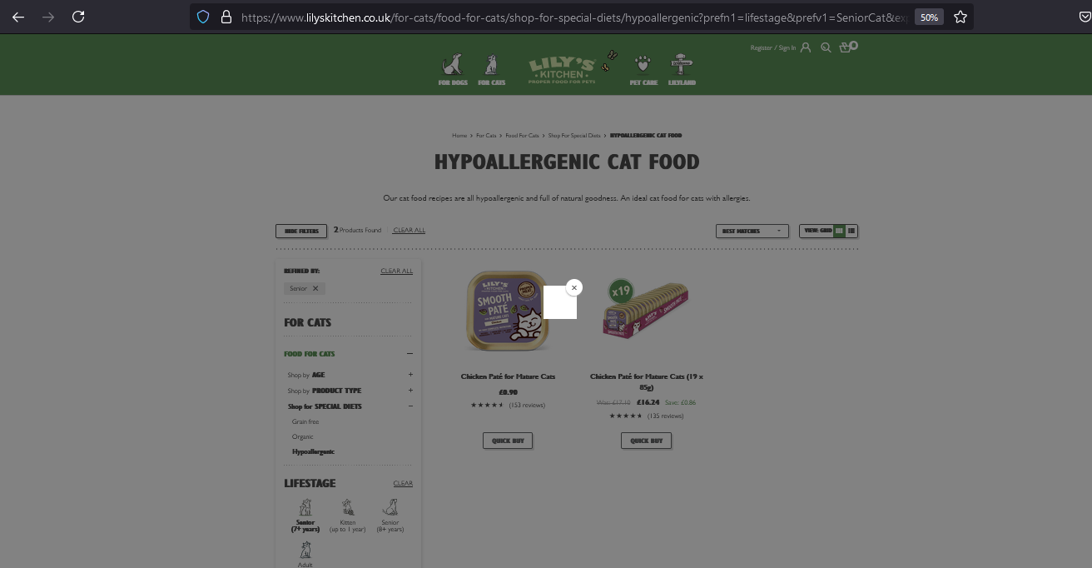

**URL:** <https://www.lilyskitchen.co.uk/for-cats/food-for-cats/shop-for-special-diets/hypoallergenic?prefn1=lifestage&prefv1=SeniorCat&expanded=2&hideFilters=false>

### **Bug 1.2:** The products list is not applied according to filter “NEWEST”

**Severity:** Major

**Environment:** Production

**Browser:** Firefox (**Reproducible on:** Google Chrome; Microsoft Edge; Opera; Huawei P40: Android 10)

**Device:** Desktop

**OS:** Windows 10 Pro

**Account:** Unregistered User

**Found by:** … and Irena Varbanova

**Methodology:** Pair-Based Exploratory testing, Operator & Navigator

**Date:** 26.06.2021

**Steps to reproduce:**

1. Open the website [**https://www.lilyskitchen.co.uk/**](https://www.lilyskitchen.co.uk/)
2. Hover FOR CATS at the green top navigation menu
3. Click on the right image below SHOP CAT
4. Scroll down
5. Click “+” at FOOD FOR CATS in the left Filter menu
6. Click “+” at Shop by AGE
7. Click “Kitten” at Shop by AGE
8. In FOOD FOR CATS click Shop for SPECIAL DIET
9. Click on “Hypoallergenic”
10. Select from the drop-down button “NEWEST” at the right of the page

**Expected result:**

Users see all the newest products first.

**Actual result:**

The User can see a products list filter by “NEWEST” which doesn’t begin with products with label “NEW”.

**Screenshots / Logs:**

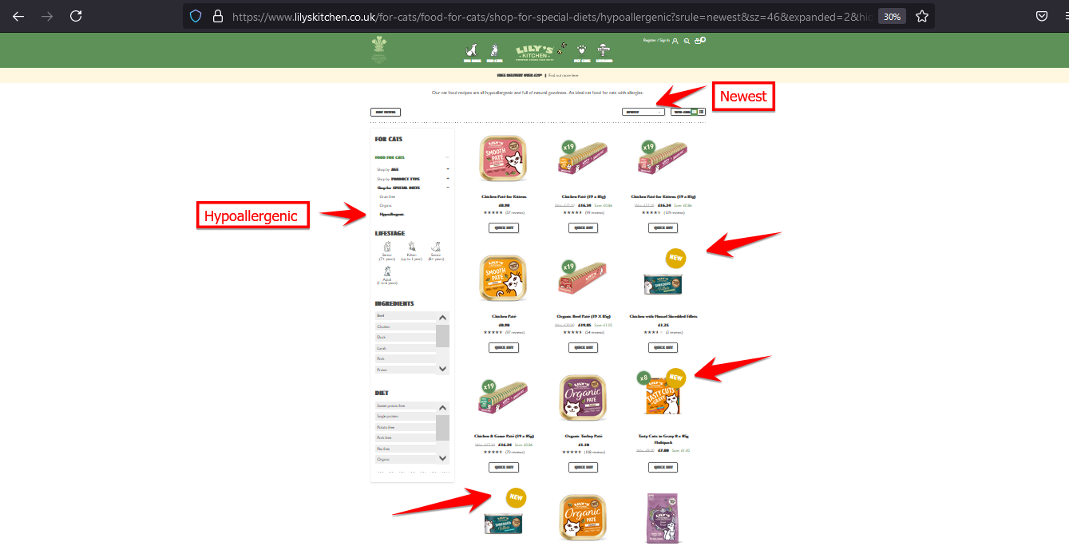

**URL:**

[**https://www.lilyskitchen.co.uk/for-cats/food-for-cats/shop-for-special-diets/hypoallergenic?srule=newest&start=0&sz=10&expanded=2&hideFilters=false**](https://www.lilyskitchen.co.uk/for-cats/food-for-cats/shop-for-special-diets/hypoallergenic?srule=newest&start=0&sz=10&expanded=2&hideFilters=false)

### **Bug 2.1:** An empty pop-up appears when the age of the dog is changed

**Severity:** Major

**Environment:** Production

**Browser:** Opera **(Reproducible on:** Google Chrome; Microsoft Edge; Firefox)

**Device:** Desktop

**OS:** Window 10 Pro

**Account:** Unregistered User

**Found by:** … and Irena Varbanova

**Methodology:** Pair-Based Exploratory Testing, Operator & Observer

**Date:** 26.06.2021

**Steps to reproduce:**

1. Open the website<https://www.lilyskitchen.co.uk/>
2. Hover over the FOR DOGS category in the top nav menu
3. Click on the “Shop All Recipes” button
4. In the Filter menu click on FOOD FOR DOGS
5. Click “+” at Shop by AGE
6. Choose and click on “Puppy”
7. Go to LIFESTAGE in the filter and click on the image of the puppy
8. Go back to Shop by AGE and click on Adult

**Expected result:** Empty list of products or a list of products suitable for both of the selected ages is expected.

**Actual result:** A pop-up appears when selecting a different age of a dog in the “Shop by Age” section of the filter.

**Screenshots / Logs:**

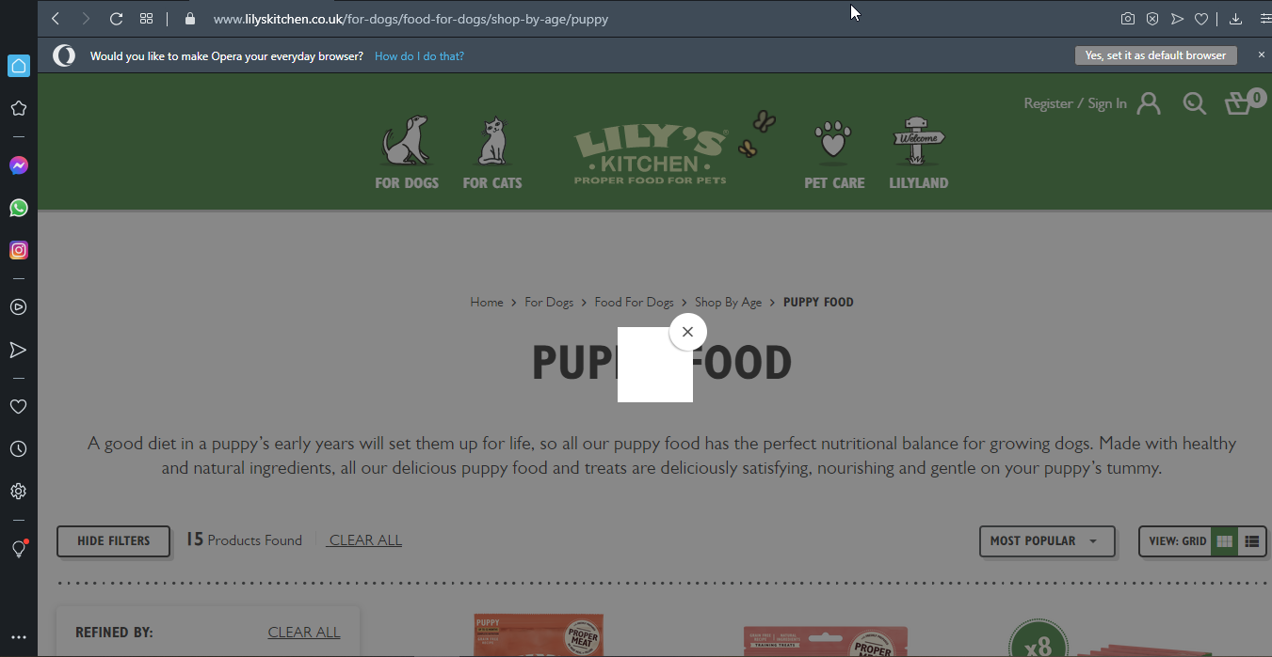

**URL:**

<https://www.lilyskitchen.co.uk/for-dogs/food-for-dogs/shop-by-age/puppy?prefn1=lifestage&prefv1=Puppy&expanded=2&hideFilters=false>

### **Bug 2.2:** “CLEAR ALL” is not working for all Filter options

**Severity:** Major

**Environment:** Production

**Browser:** Opera Version (**Reproducible on:** Google Chrome; Mozilla Firefox; Microsoft Edge)

**Device:** Desktop

**OS:** Window 10 Pro

**Account:** Unregistered User

**Found by:** … and Irena Varbanova

**Testing Methodology:** Pair-Based Exploratory testing, Operator & Observer

**Date:** 26.06.2021

**Steps to reproduce:**

1. Open the website[**https://www.lilyskitchen.co.uk/**](https://www.lilyskitchen.co.uk/)
2. Scroll down
3. Click on ”Menu FOR DOGS>>”
4. Click on “+” at FOOD FOR DOGS in the Filter menu
5. Click on “+” at Shop by AGE”
6. Click on the “Adult” category
7. Click on “Adult” in LIFESTAGE
8. Click on “Puppy” at Shop by AGE
9. Close the appeared pop-up image
10. Click “CLEAR ALL” at the Filer menu

**Expected result:**

The User expected to delete all made choices after clicking on “CLEAR ALL”.

**Actual result:**

The User can see that there is a category which stays marked.

**Screenshots / Logs:**

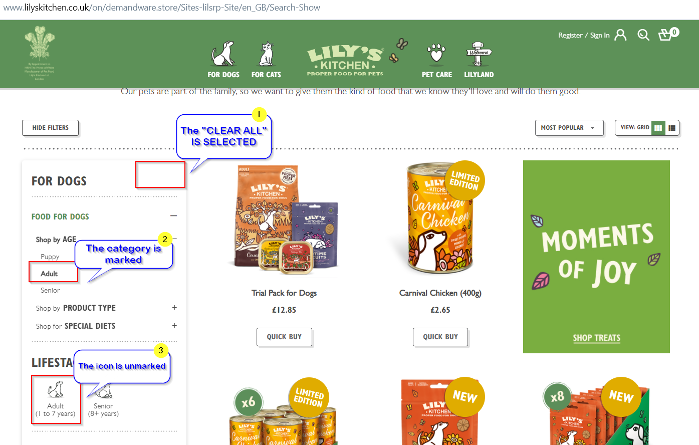

**URL:** [**https://www.lilyskitchen.co.uk/for-dogs/food-for-dogs/shop-by-age/adult?prefn1=lifestage&prefv1=Adult&expanded=2&hideFilters=false**](https://www.lilyskitchen.co.uk/for-dogs/food-for-dogs/shop-by-age/adult?prefn1=lifestage&prefv1=Adult&expanded=2&hideFilters=false)

### **Bug 2.3:** Filtering by “NEWEST” is not applied

**Severity:** Major

**Environment:** Production

**Browser:** Opera (**Reproducible on:** Google Chrome; Firefox, Microsoft Edge)

**Device:** Desktop

**OS:** Window 10 Pro

**Account:** Unregistered User

**Found by:** … and Irena Varbanova

**Testing Methodology:** Pair-Based Exploratory testing, Operator & Observer

**Date:** 26.06.2021

**Steps to reproduce:**

1. Open the website[**https://www.lilyskitchen.co.uk/**](https://www.lilyskitchen.co.uk/)
2. Scroll down
3. Click on ”Menu FOR DOGS>>”
4. In the Filter menu click on “Adult” in LIFESTAGE
5. Scroll down to the bottom of the page
6. After the product’s list click on “Show All (133)”
7. Go back to the top of the page
8. Select from drop down button “NEWEST”

**Expected result:**

The User should see products filtered by “NEWEST”.

**Actual result:**

The User can see products not matching the chosen filter “NEWEST”.

**Screenshots / Logs:**

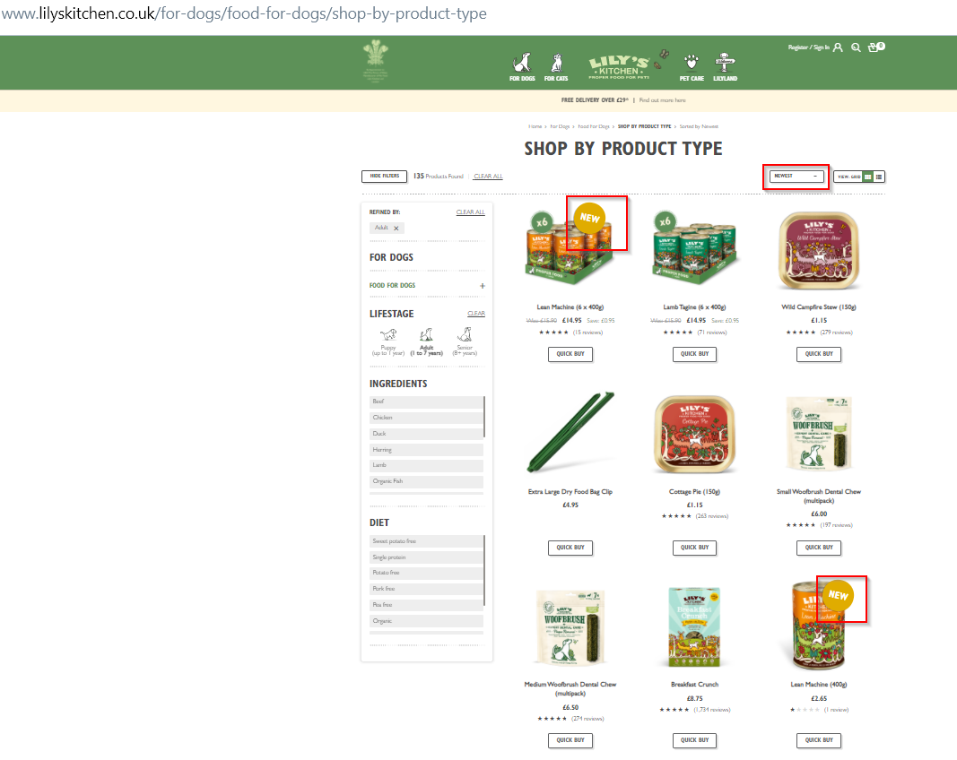

**URL:** [**https://www.lilyskitchen.co.uk/for-dogs/food-for-dogs/shop-by-product-type?prefn1=lifestage&prefv1=Adult&srule=newest&start=0&sz=135&hideFilters=false**](https://www.lilyskitchen.co.uk/for-dogs/food-for-dogs/shop-by-product-type?prefn1=lifestage&prefv1=Adult&srule=newest&start=0&sz=135&hideFilters=false)

**Other:**

We tried filtering by “NEWEST” for “Puppy” and “Senior” - it’s reproducible also for them that the Filter “NEWEST” is not applied.

We tried filtering by “NEWEST” for “Adult” for Mobile Device - it’s reproducible also for it that the Filter “NEWEST” is not applied.

### **Bug 2.4:** Controversial options in the left Filter are applied

**Severity:** Major

**Environment:** Production

**Browser:** Opera (**Reproducible on:** Google Chrome; Firefox, Microsoft Edge)

**Device:** Desktop

**OS:** Window 10 Pro

**Account:** Unregistered User

**Found by:** … and Irena Varbanova

**Testing Methodology:** Pair-Based Exploratory testing, Operator & Observer

**Date:** 26.06.2021

**Steps to reproduce:**

1. Open the website<https://www.lilyskitchen.co.uk/>
2. Click on the FOR DOGS category from the menu
3. Click on the “Shop All Dogs Recipes” button
4. From the filter select ingredient “Chicken” and diet “Chicken-free”
5. Press “Clear All”
6. From the filter select ingredient “Pork” and diet “Pork-free”

**Expected result:**

The criteria chosen in the filter are controversial. So, the filter is expected to return an empty list of products, both, on step 4 and on step 6.

**Actual result:**

There is one product filtered, both on step 4, and on step 6.

**Screenshots / Logs:**

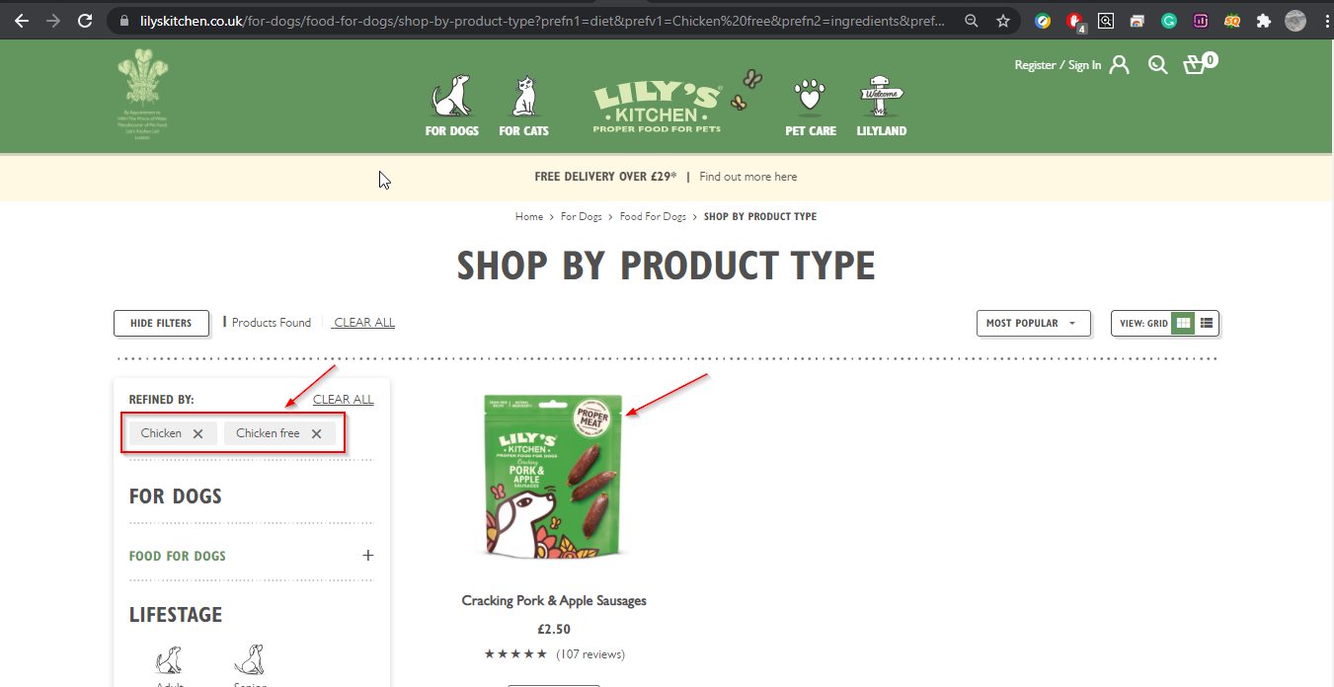

**URL:**

[**https://www.lilyskitchen.co.uk/for-dogs/food-for-dogs/shop-by-product-type?prefn1=diet&prefv1=Chicken%20free&prefn2=ingredients&prefv2=Chicken&hideFilters=false**](https://www.lilyskitchen.co.uk/for-dogs/food-for-dogs/shop-by-product-type?prefn1=diet&prefv1=Chicken%20free&prefn2=ingredients&prefv2=Chicken&hideFilters=false)

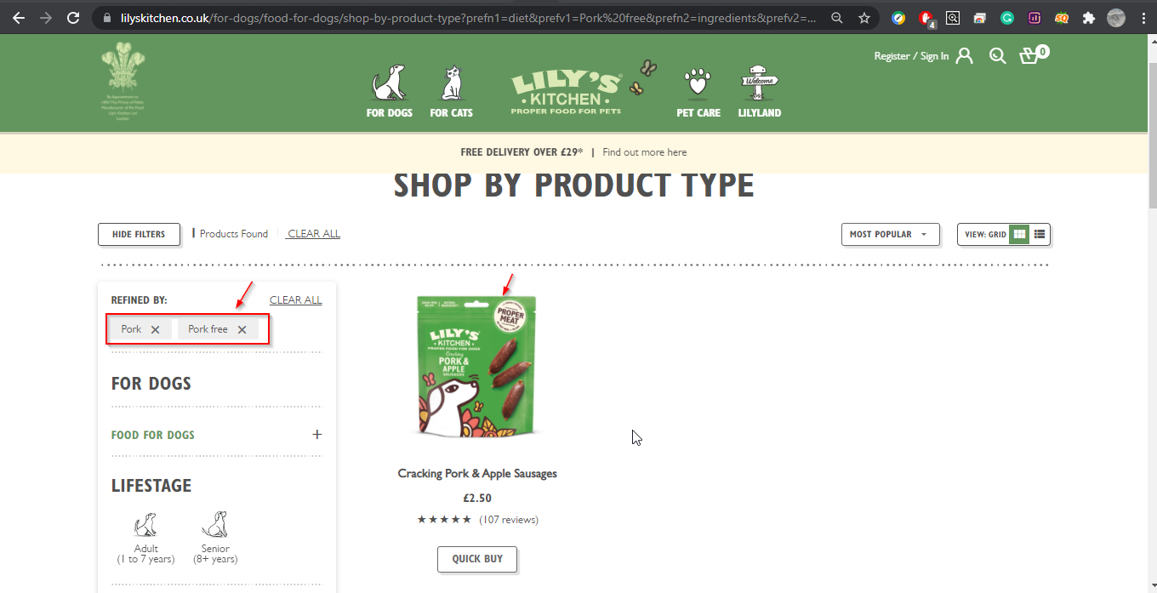

**URL:**<https://www.lilyskitchen.co.uk/for-dogs/food-for-dogs/shop-by-product-type?prefn1=diet&prefv1=Pork%20free&prefn2=ingredients&prefv2=Pork&hideFilters=false>

### **Bug 4.1:** No limit or content check for promo code field

**Severity:** Major

**Environment:** https://www.lilyskitchen.co.uk/

**Browser:** Google Chrome (**Reproducible** on Microsoft Edge, Mozilla Firefox)

**Device:** Desktop

**OS:** Windows 10

**Account:** Unregistered User

**Found by:** … and …

**Testing Methodology:** Pair-based Exploratory Testing; Navigator & Operator

**Date: 24.06.06 18:30**

**Steps to reproduce:**

1. Open the website<https://www.lilyskitchen.co.uk/>
2. Add any item to the basket
3. Open the basket
4. Enter the promocode field
5. Enter any value with any length (5000 random symbols)
6. Verify the result

**Expected result:** String length should be checked and only Letters and numbers should be allowed.

**Actual result:** Over 5000 symbols put the system on hold for about 20 seconds, after that it returns the whole string as part of an error message, that goes out of the screen bounds.

**Screenshots / Logs:**

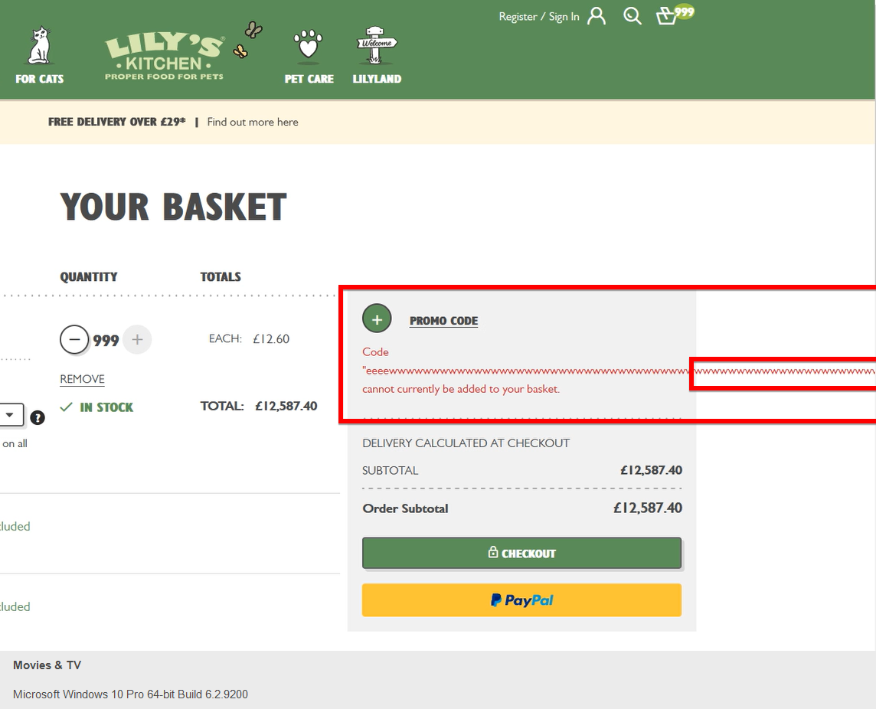

**URL:**

<https://www.lilyskitchen.co.uk/>

**Other:**

Serious security issue, possible SQL injection risk

## Normal Severity

### **Bug 1.3:** Missing cat’s icons at LIFESTAGE

**Severity:** Normal

**Environment:** Production

**Browser:** Firefox (**Reproducible on:** Google Chrome; Microsoft Edge; Opera)

**Device:** Desktop

**OS:** Windows 10 Pro

**Account:** Unregistered User

**Found by:** … and Irena Varbanova

**Testing Methodology:** Pair-Based Exploratory testing, Operator & Navigator

**Date:** 26.06.2021

**Steps to reproduce:**

1. Open the website<https://www.lilyskitchen.co.uk/>
2. Hover FOR CATS at the green top navigation menu
3. Click on the right image below SHOP CAT
4. Scroll down and look at to the left Filter menu

**Expected result:**

The User should see in LIFESTAGE all age icons of a cat.

**Actual result:**

The User can see only one age icon of a cat in LIFESTAGE - “Adult (1-6 years)”.

**Screenshots / Logs:**

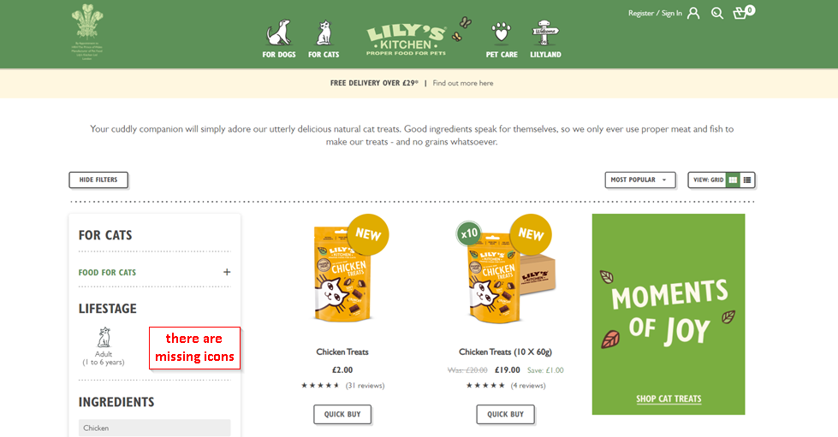

**URL:** <https://www.lilyskitchen.co.uk/for-cats/food-for-cats/shop-by-product-type/treats>

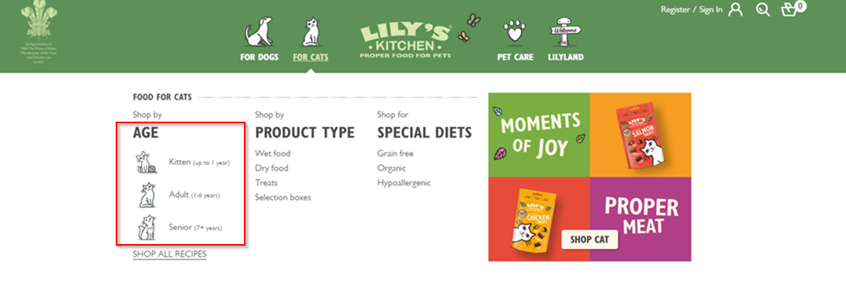

### **Bug 1.4:** Inappropriate icon at LIFESTAGE and mismatching products

**Severity:** Normal

**Environment:** Production

**Browser:** Firefox (**Reproducible on:** Google Chrome; Microsoft Edge; Opera)

**Device:** Desktop

**OS:** Windows 10 Pro

**Account:** Unregistered User

**Found by:** … and Irena Varbanova

**Testing Methodology:** Pair-Based Exploratory testing, Operator & Navigator

**Date:** 26.06.2021

**Steps to reproduce:**

1. Open the website<https://www.lilyskitchen.co.uk/>
2. Hover FOR CATS at the green top navigation menu
3. Click on the right image below SHOP CAT
4. Scroll down, click “+” on Shop by AGE in the left Filter menu
5. Click on the dog icon

**Expected result:**

The User should see 3 age icons of a cat.

**Actual result:**

The User can see 1 age icon of a dog. After selecting the icon of a dog in the product’s list there are 2 cat’s products.

**Screenshots / Logs:**

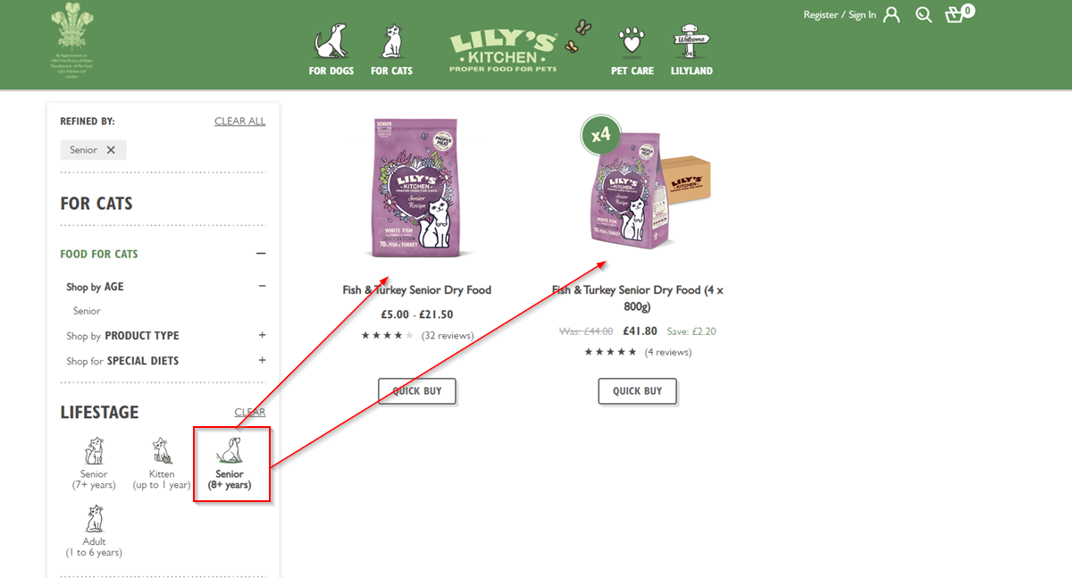

**URL:** <https://www.lilyskitchen.co.uk/for-cats/food-for-cats/shop-by-age?&expanded=2>

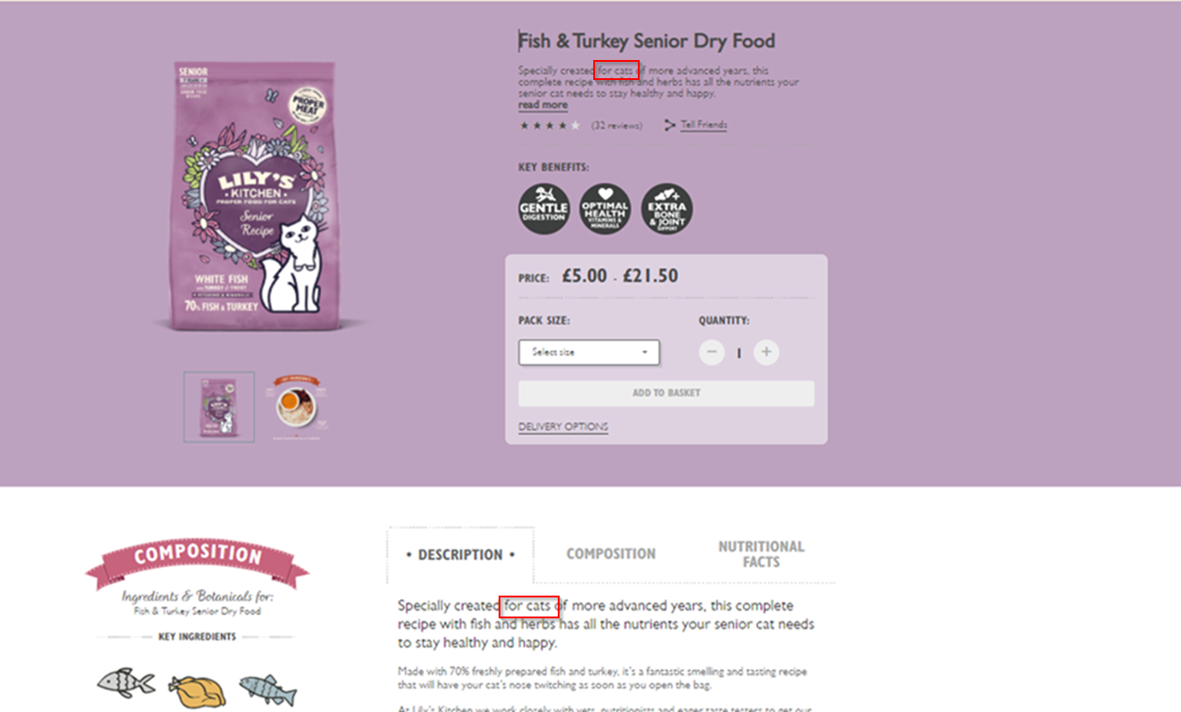

**URL:**https://www.lilyskitchen.co.uk/for-cats/food-for-cats/shop-by-age?prefn1=lifestage&prefv1=Senior&expanded=2&hideFilters=false

### **Bug 1.5:** Incorrect CATS age's icons line in CAT’S LIFESTAGE

**Severity:** Normal

**Environment:** Production

**Browser:** Firefox (**Reproducible on:** Google Chrome; Microsoft Edge; Opera)

**Device:** Desktop

**OS:** Windows 10 Pro

**Account:** Unregistered User

**Found by:** … and Irena Varbanova

**Testing Methodology:** Pair-Based Exploratory testing, Operator & Navigator

**Date:** 26.06.2021

**Steps to reproduce:**

1. Open the website<https://www.lilyskitchen.co.uk/>
2. Hover FOR CATS at the green top navigation menu
3. Click on the right image below SHOP CAT
4. Scroll down
5. Click FOOD FOR CATS in the left Filter menu
6. Select “Pork” in INGREDIENTS

**Expected result:**

The User should see the cat's age icons line in the LIFESTAGE in the proper manner.

**Actual result:**

The User can see incorrect cat’s age icons line in the LIFESTAGE.

**Screenshots / Logs:**

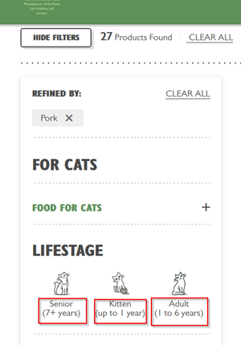

**URL:**

<https://www.lilyskitchen.co.uk/for-cats/food-for-cats?prefn1=ingredients&prefv1=Pork&hideFilters=false>

**Other:** REPRODUCIBLE onMobile Device Huawei P40 Lite, OS EMUI 10.0.1 (Based on Android 10.0)

### **Bug 2.5:** Filtering by age in the left Filter is not applied

**Severity:** Normal

**Environment:** Production

**Browser:** Opera Version (**Reproducible on** Google Chrome; Microsoft Edge; Mozilla Firefox)

**Device:** Desktop

**OS:** Window 10 Pro

**Account:** Unregistered User

**Found by:** … and Irena Varbanova

**Testing Methodology:** Pair-Based Exploratory Testing, Operator & Observer

**Date:** 26.06.2021

**Steps to reproduce:**

1. Open the website<https://www.lilyskitchen.co.uk/>
2. Hover over the FOR DOGS category in the top navigation menu
3. Click on the “Shop All Recipes” button
4. In the Filter menu click on FOOD FOR DOGS
5. Click “+” at Shop by AGE
6. Choose and click on “Puppy”
7. Go back to Shop by AGE and click on “Adult”
8. Go back to Shop by AGE and click on “Senior”

**Expected result:** In LIFESTAGE there should be the corresponding image of the dog of the same age If in the filter “Shop by Age” a dog’s age is chosen.

**Actual result:** When selecting “Senior” or “Adult” in “Shop by Age” in the filter, in both cases, there are two images of dogs in LIFESTAGE.

**Screenshots / Logs:**

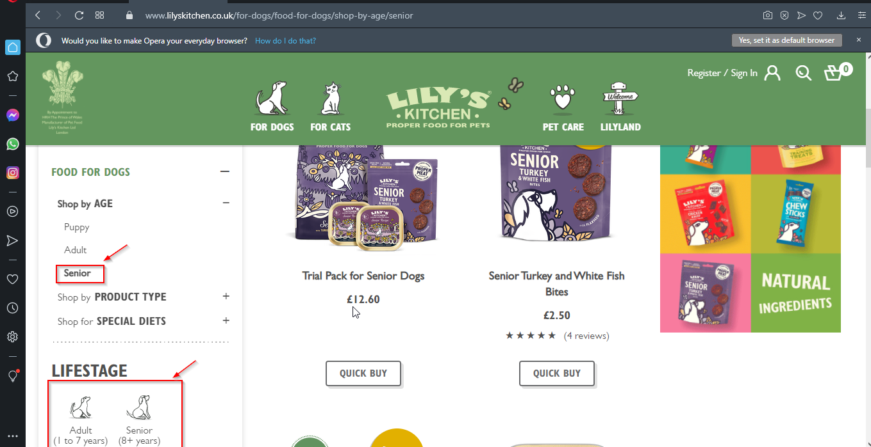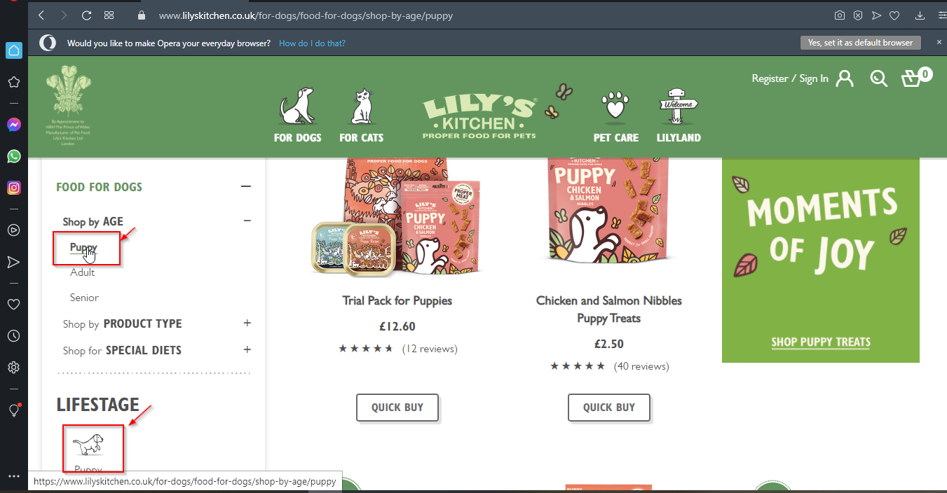

**URL:**

https://www.lilyskitchen.co.uk/for-dogs/food-for-dogs/shop-by-age/senior?expanded=2&hideFilters=false

**Other:**

REPRODUCIBLE onMobile Device Huawei P40 Lite, OS EMUI 10.0.1 (Based on Android 10.0)

### **Bug 4.2:** Searching with 2 letters and * returns results

**Severity:** Normal

**Environment:** https://www.lilyskitchen.co.uk/

**Browser:** Google Chrome(**Reproducible** on Edge, Mozilla Firefox, Android 9)

**Device: Desktop**

**OS:** Windows 10

**Account:** Unregistered User

**Found by:** … and …

**Testing Methodology:** Pair-based Exploratory Testing; Operator & Navigator, Couch-potato

**Date:** 24.06.2021 16:32

**Steps to reproduce:**

1. Open the website<https://www.lilyskitchen.co.uk/>;
2. Select the search options;
3. Enter the value “re” and initialize search;
4. Verify the result;
5. Search again for “recipe”
6. Verify the result
7. Search again with the value “re*”;
8. Verify the result;

**Expected result:** Part of the phrase “recipe” should return results (re) and special logical symbol for “any” should not be included.

**Actual result:** Search of re* returns results as if it’s a complete a phrase.

**Screenshots / Logs:**

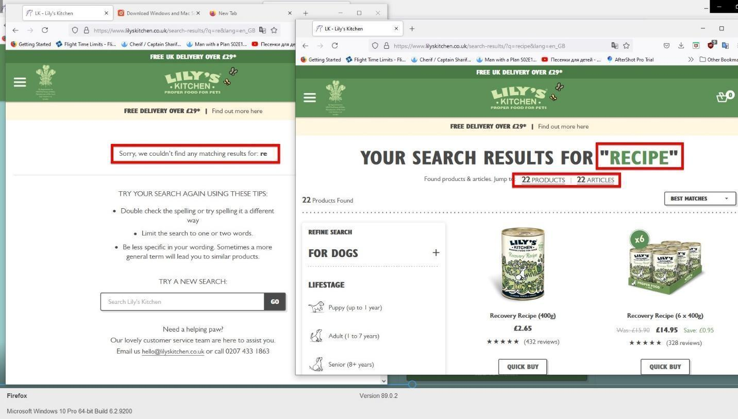

**URL:** <https://www.lilyskitchen.co.uk/>

**Other:** Bug is reported as “*” could be used as part of an SQL injection. Raise attention to Project Owner and Developers if Special symbols should be allowed in Client-side search.

### **Bug 4.3:** Bug for wrong return of search results

**Severity:** Normal

**Environment:** https://www.lilyskitchen.co.uk/

**Browser:** Google Chrome (**Reproducible** on Edge, Mozilla Firefox)

**Device: Desktop**

**OS:** Windows 10, Windows 11

**Account:** Unregistered User

**Found by:** … and …

**Testing Methodology:** Pair-based Exploratory Testing; Navigator & Operator

**Date: 24.06.06 16:25**

**Steps to reproduce:**

1. Open the website<https://www.lilyskitchen.co.uk/>;
2. Select the search options;
3. Enter an invalid string (Lili, LILI (site name is LILY));
4. Initiate the search;
5. Open any of the products/articles (218/60 found);
6. Using CTRL + F search the page for Lili; LILI**;**
7. Repeat steps 4-6 for:

<https://www.lilyskitchen.co.uk/for-dogs/food-for-dogs/shop-by-product-type/extras/compostable-poo-bags-DWBAG60.html>

<https://www.lilyskitchen.co.uk/for-dogs/food-for-dogs/shop-by-product-type/extras/extra-large-dry-food-bag-clip-LKMCLIP01.html>

**Expected result:** Phrase Lili should be visible in any part of the product (description/composition/nutrition) or no results should appear

**Actual result:** Phrase Lili is not present anywhere in the opened items and search has results

**Screenshots / Logs:**

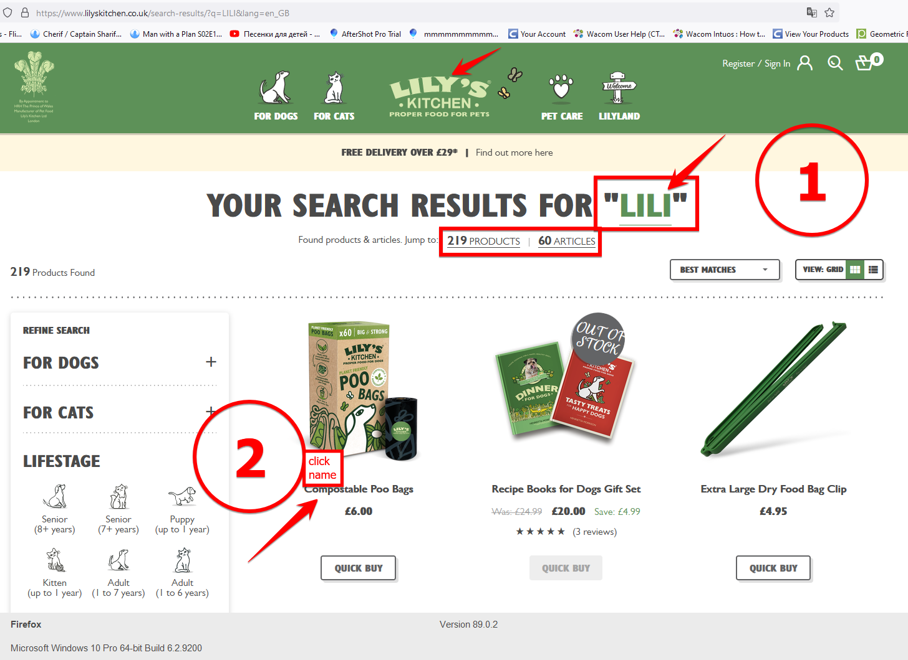

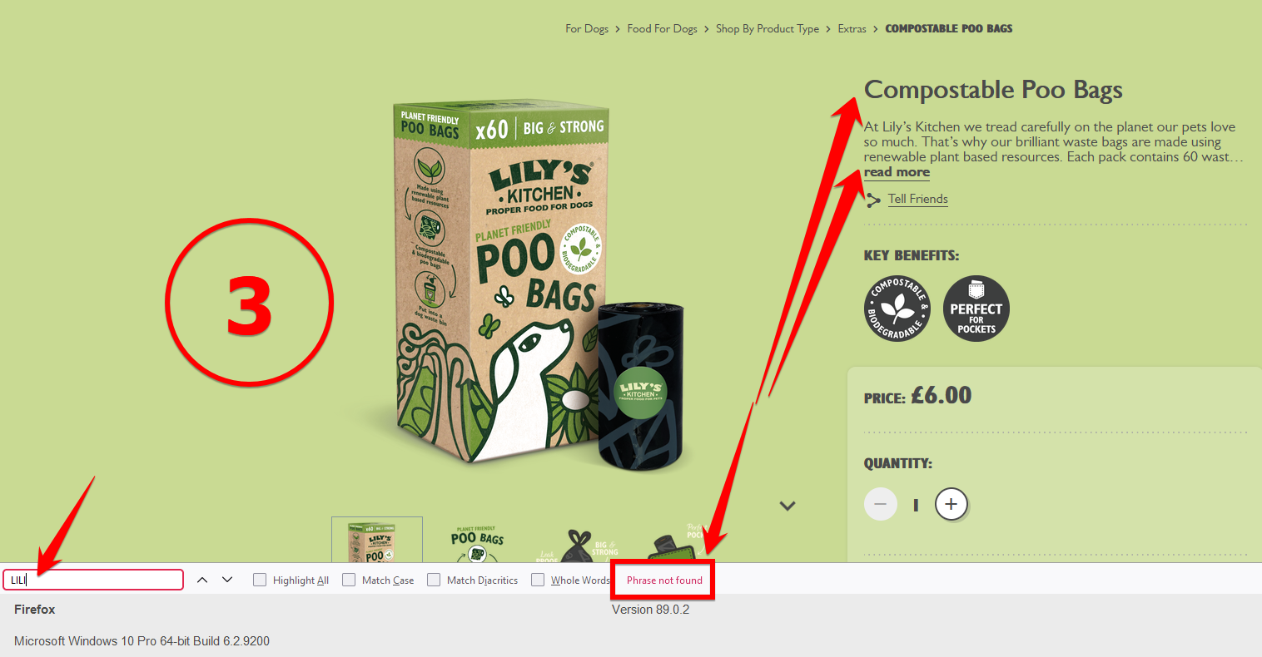

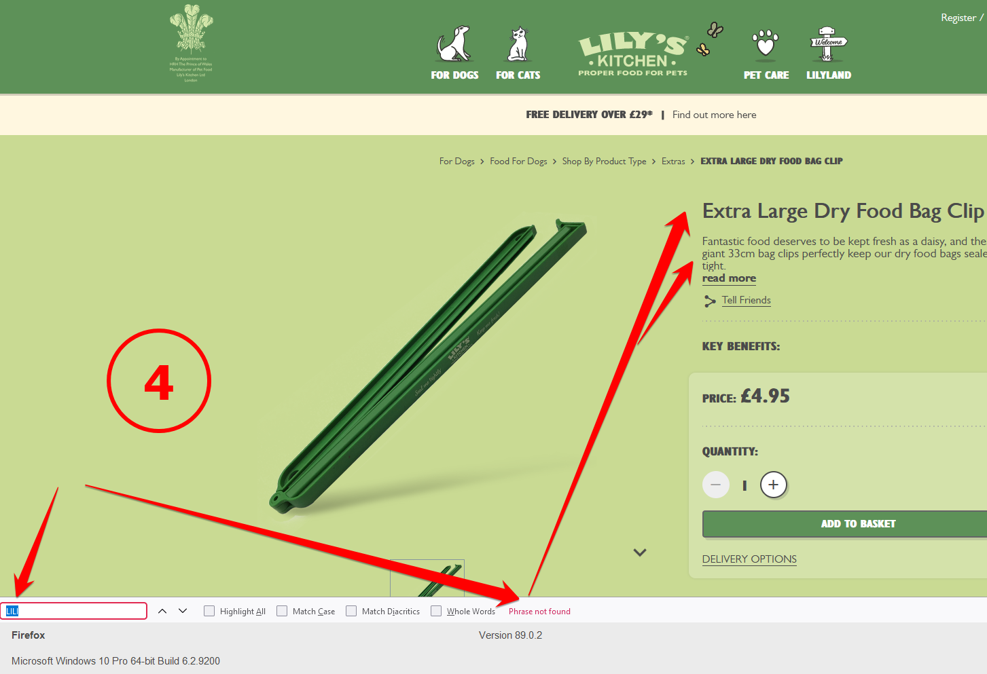

**URL:**

<https://www.lilyskitchen.co.uk/>

<https://www.lilyskitchen.co.uk/for-dogs/food-for-dogs/shop-by-product-type/extras/compostable-poo-bags-DWBAG60.html>

<https://www.lilyskitchen.co.uk/for-dogs/food-for-dogs/shop-by-product-type/extras/extra-large-dry-food-bag-clip-LKMCLIP01.html>

### **Bug 4.4:** Holding Enter decreases item quantity in basket

**Severity:** Normal

**Environment:** <https://www.lilyskitchen.co.uk/>

**Browser:** Google Chrome (**Reproducible** on Mozilla Firefox)

**Device:** Desktop

**OS:** Windows 10

**Account:** Unregistered User

**Found by:** … and …

**Testing Methodology:** Pair-based Exploratory Testing; Navigator & Operator

**Date:** 24.06.06 16:38

**Steps to reproduce:**

1. Open the website<https://www.lilyskitchen.co.uk/>
2. Go to Food for dogs
3. Open Puppy
4. Select Trial Pack for Puppies
5. Select Quick Buy
6. Add 77 to the basket
7. Return to Puppy food screen.
8. Select Quick buy for Trial Pack for Puppies.
9. Enter “-7” and select add to basket.
10. Return to Puppy food screen.
11. Select Quick buy for Trial Pack for Puppies.
12. Enter value “199” and do not click add to basket
13. While on the value field, hold the “Enter Key”
14. Verify the result

**Expected result:** 199 items should be added in the basket**.**

**Actual result: Items in the amount field start to rapidly decrease on both the screen and on the basket Icon**

**URL:** <https://www.lilyskitchen.co.uk/>

**Screenshots / Logs:**

**Other:** Each decrease was achieved by pressing the Enter key on the keyboard

### **Bug 4.5:** Misleading message for non-applied promo code

**Severity:** Normal

**Environment:** <https://www.lilyskitchen.co.uk/>

**Browser:** Google Chrome(**Reproducible on** Android 9**)**

**Device:** Desktop

**OS:** Windows 10

**Account:** Unregistered User

**Found by:** … and …

**Testing Methodology:** Pair-based Exploratory Testing; Navigator & Operator, Yellow Hat

**Date:** 24.06.06 16:45

**Steps to reproduce:**

1. Open the websitehttps://www.lilyskitchen.co.uk/
2. Open the shop and add any item to the basket.
3. Open the basket and select “Promo Code”
4. Add “LILYSWELCOME”
5. Verify that the amount that the promo code deducts from the total price.
6. Select to add a second promo code “PROPERWELCOME” (Both codes have a 10% off)
7. Verify the amount that the promo code deducts from the total price.

**Expected result:** Since the systems allows for more than one code to be used, both should apply

**Actual result:** Only the second or the higher price deduction code is used, and both codes are marked with a checkbox and are marked in green.

**Screenshots / Logs:**

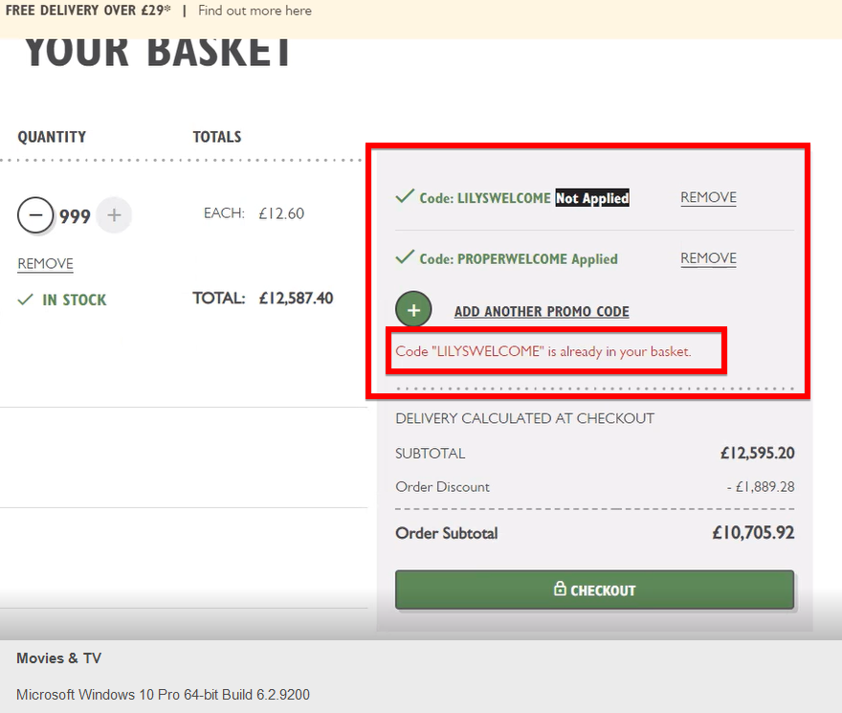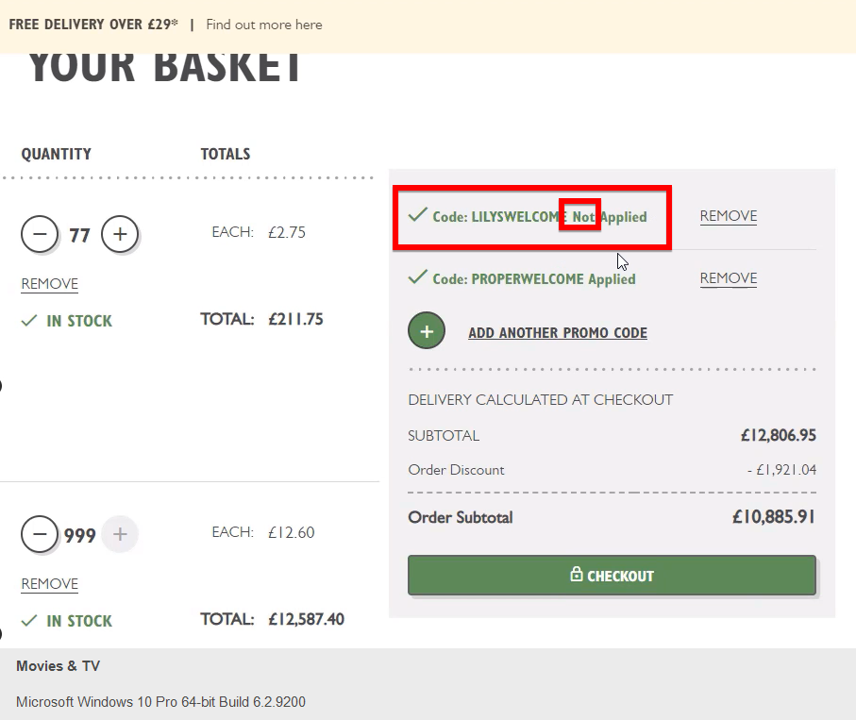

**URL:**

<https://www.lilyskitchen.co.uk/>

**Other:**

Tried adding a third code with a different result, that got 2 codes apply

### **Bug 4.6:** Nonfood items labeled as such

**Severity:** Normal

**Environment:** <https://www.lilyskitchen.co.uk/>

**Browser:** Chrome(**Reproducible** on Microsoft Edge, Mozilla Firefox)

**Device:** Desktop

**OS:** Windows 10

**Account:** Unregistered User

**Found by:** … and …

**Testing Methodology:** Pair-based Exploratory Testing; Navigator & Operator

**Date: 24.06.06**

**Steps to reproduce:**

1. Open the website<https://www.lilyskitchen.co.uk/>
2. Open the Extra-Large Dry Food Bag Clip
3. Go to description
4. Verify the Composition button and nutritional facts

**Expected result:** Nonfood items should not have a banner for Ingredients, a special button for composition and a separate tab for Nutritional Facts.

**Actual result:** A banner for “Ingredients and Botanicals”, a “View Composition” and a Nutritional Facts is present for non-digestive item

**Screenshots / Logs:**

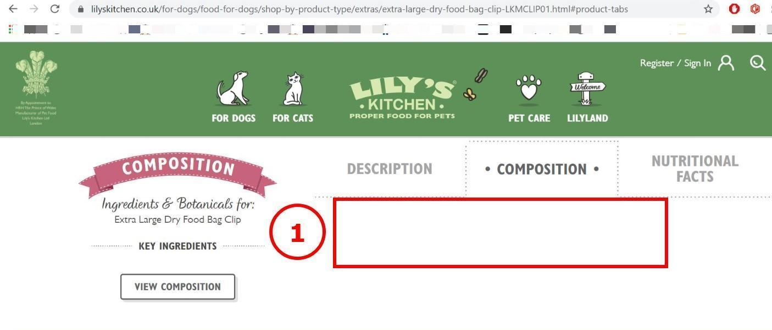

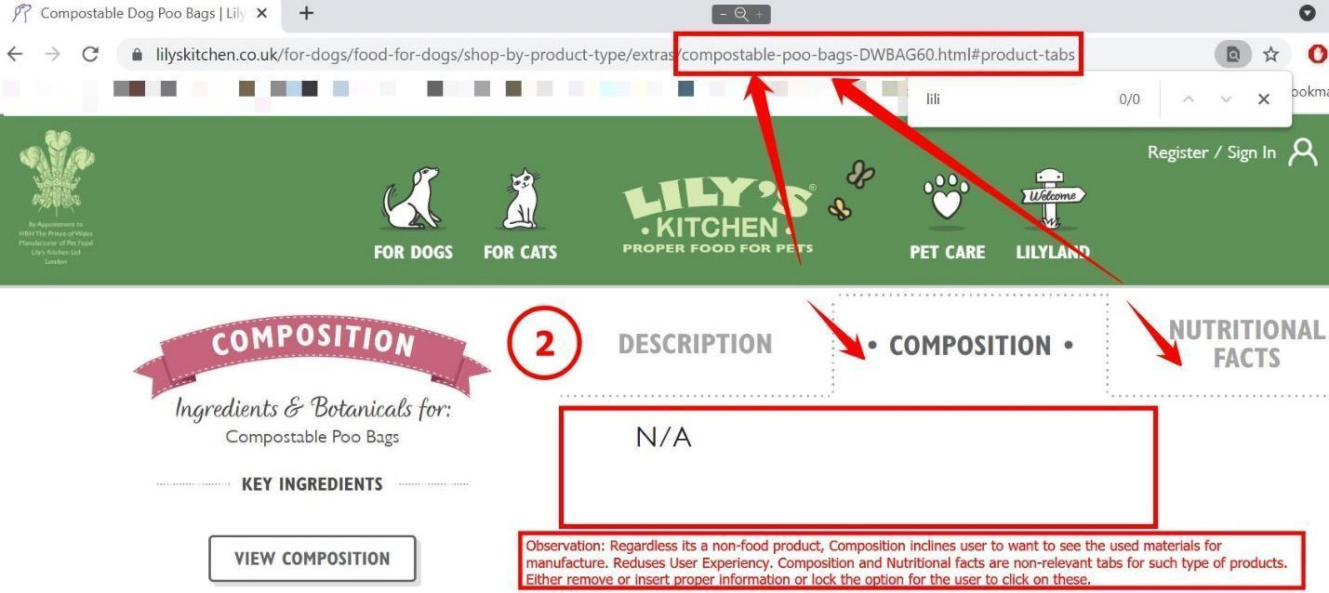

**URL:**

<https://www.lilyskitchen.co.uk/>

### Bug 4.7: **Entering non-numeric value resets the field**

**Severity:** Minor

**Environment:** <https://www.lilyskitchen.co.uk/>

**Browser:** Google Chrome(**Reproducible** on Edge, Mozilla Firefox)

**Device: Desktop**

**OS:** Windows 10

**Account:** Unregistered User

**Found by:** … and …

**Testing Methodology:** Pair-based Exploratory Testing; Operator & Navigator, Anti-social type

**Date:** 24.06.2021 16:36

**Steps to reproduce:**

1. Open the website<https://www.lilyskitchen.co.uk/>
2. Open any item (<https://www.lilyskitchen.co.uk/for-dogs/food-for-dogs/shop-by-age/puppy/chicken-and-salmon-nibbles-puppy-treats-DTSPN.html>)
3. Add 2 to the Basket
4. Open the Basket
5. Enter “ff” in the amount field and hit enter
6. Verify the field value.

**Expected result:**  Value should remain unchanged (2) and a warning message should be generated

**Actual result:** Value is reset to 1 (lowest positive).

**Attached files:**

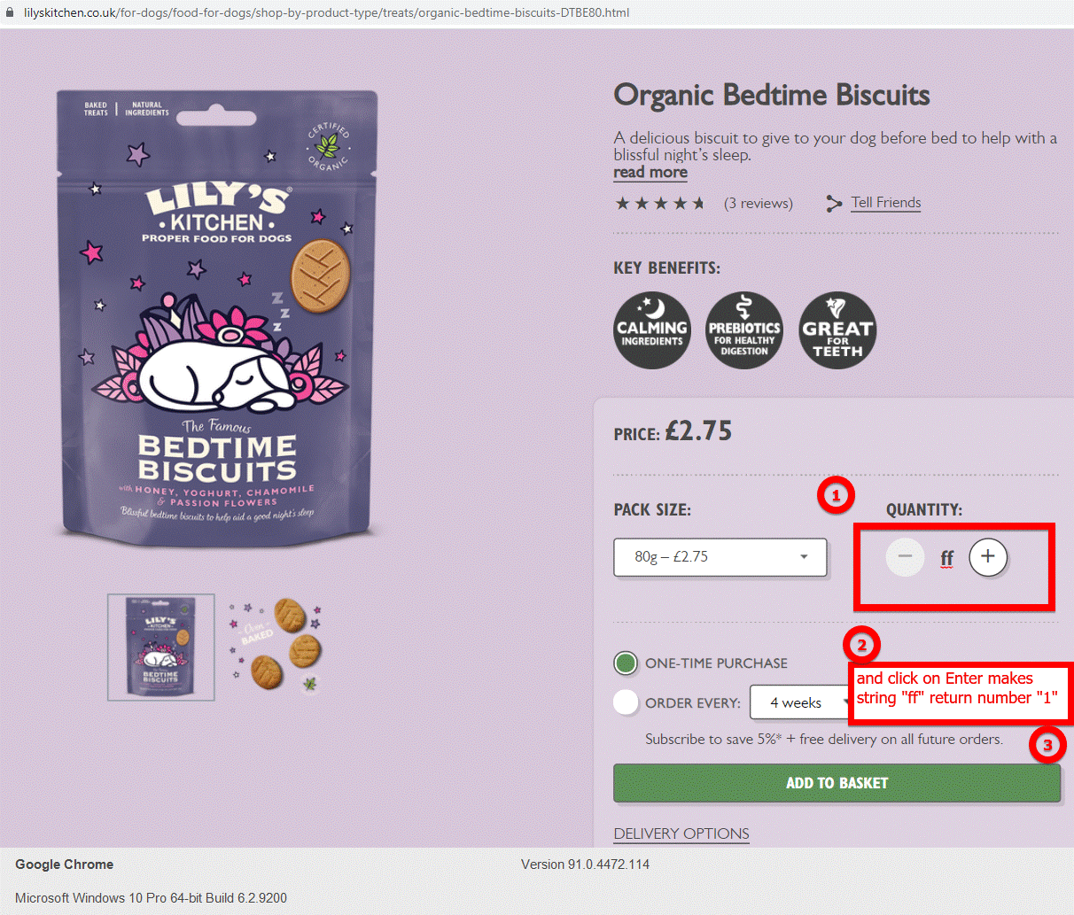

**URL:**

<https://www.lilyskitchen.co.uk/>

**Other:**

We tried entering non numeric special symbols with the same result

## Minor Severity

### **Bug 2.6:** The “Next” button remains inactive in section “Feeding Guidelines”

**Severity:** Minor

**Environment:** Production

**Browser:** Opera(**Reproducible on:** Google Chrome; Mozilla Firefox; Microsoft Edge)

**Device:** Desktop

**OS:** Window 10 Pro

**Account:** Unregistered User

**Found by:** … and Irena Varbanova

**Testing Methodology:** Pair-Based Exploratory testing, Operator & Observer

**Date:** 26.06.2021

**Steps to reproduce:**

1. Open the website<https://www.lilyskitchen.co.uk/>
2. Hover over the FOR DOGS category in the top nav menu
3. Click on the “Shop All Recipes” button
4. Open one of the products in the list
5. Go down the page to the section “Feeding Guidelines”
6. Select “Your dog”
7. Press the START button
8. Choose “Puppy 2-4 months”
9. Press NEXT
10. Enter dog’s weight:“2” in the first input field - **The NEXT button is inactive**
11. Click on the NEXT button - now the button is active
12. Press NEXT once again to move on to the next step.

**Expected result:**

When clicking NEXT the user is expected to move to the next step of the Feeding Guidelines.

**Actual result:**

When filling in the weight of the dog in the first input field, the NEXT button is inactive on the first click.

**Screenshots / Logs:**

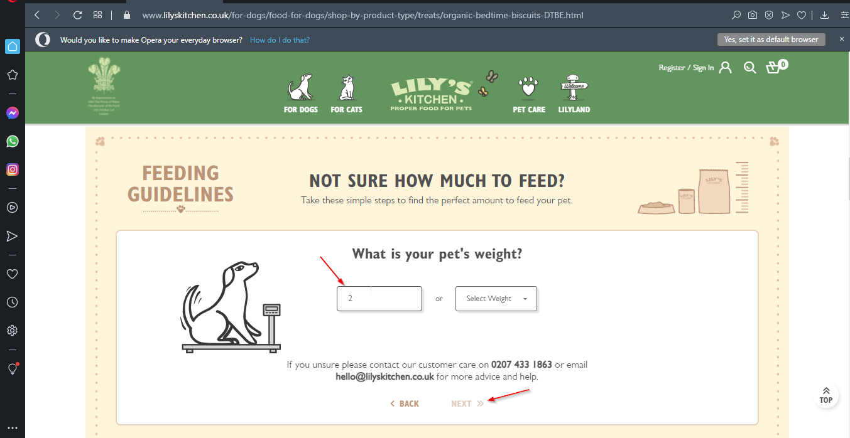

**URL:**

[A](https://www.lilyskitchen.co.uk/for-dogs/food-for-dogs/shop-by-age/puppy?prefn1=lifestage&prefv1=Puppy&expanded=2&hideFilters=false)ny page where a product is viewed. For example:

<https://www.lilyskitchen.co.uk/for-dogs/food-for-dogs/shop-by-product-type/treats/organic-bedtime-biscuits-DTBE.html>

### **Bug 3.1:** Poor visibility of text with hyperlink in News page

**Severity:** Minor

**Environment:** Production

**Browser:** Google Chrome (**Reproducible on:** Microsoft Edge, Firefox, Opera)

**Device:** Desktop

**OS:** Windows 10

**Account:** Unsigned User

**Found by:** … and …

**Testing Methodology:** Pair-Based testing: Operator & Observer; The Landmark Tour

**Date:** 25.06.2021

**Steps to reproduce:**

1. Go to <https://www.lilyskitchen.co.uk/lilyland/our-world/about-lilys-kitchen/news.html>

**Expected result:** Some way to distinguish normal text from text with a hyperlink

**Actual result:** Normal text and text with hyperlink blend completely

**Screenshots / Logs:** :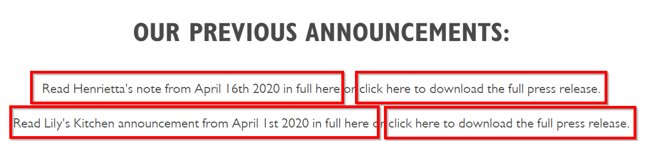

**URL:** <https://www.lilyskitchen.co.uk/lilyland/our-world/about-lilys-kitchen/news.html>

### **Bug 4.8:** Search returns obsolete item

**Severity:** Minor

**Environment:** <https://www.lilyskitchen.co.uk/>

**Browser:** Google Chrome (**Reproducible** on Mozilla Firefox)

**Device:** Desktop

**OS:** Windows 10

**Account:** Unregistered User

**Found by:** … and …

**Testing Methodology:** Pair-based Exploratory Testing; Navigator & Operator

**Date:** 24.06.21

**Steps to reproduce:**

1. Open the website<https://www.lilyskitchen.co.uk/>
2. Open the search options
3. Enter the value “organic bedtime biscuits” and search
4. Verify the results.

**Expected result:** Only items matching the description should be present

**Actual result:** A calendar is present in the search results.

**Screenshots / Logs:**

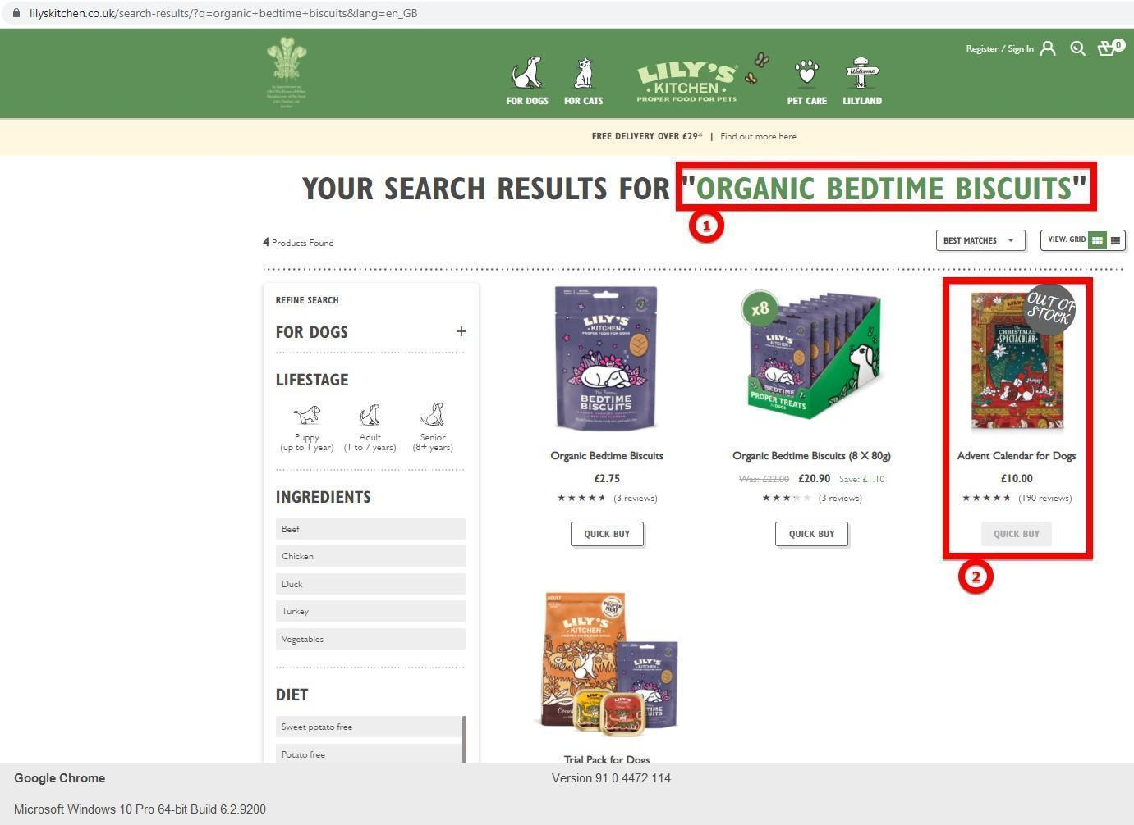

**URL:**

<https://www.lilyskitchen.co.uk/>

### **Bug 4.9:** Using a special symbol in search returns results

**Severity: Minor**

**Environment:** https://www.lilyskitchen.co.uk/

**Browser:** Google Chrome (**Reproducible** on Microsoft Edge, Mozilla Firefox)

**Device:** Desktop

**OS:** Windows 10

**Account:** Unregistered User

**Found by:** … and …

**Testing Methodology:** Pair-based Exploratory Testing; Navigator & Operator

**Date:** 24.06.21

**Steps to reproduce:**

1. Open the website<https://www.lilyskitchen.co.uk/>
2. Open the search options
3. Enter the value “g^” and search
4. Verify the results.

**Expected result:** As a non-valid input, no results should be found

**Actual result:** 158 results are generated.

**Screenshots / Logs:**

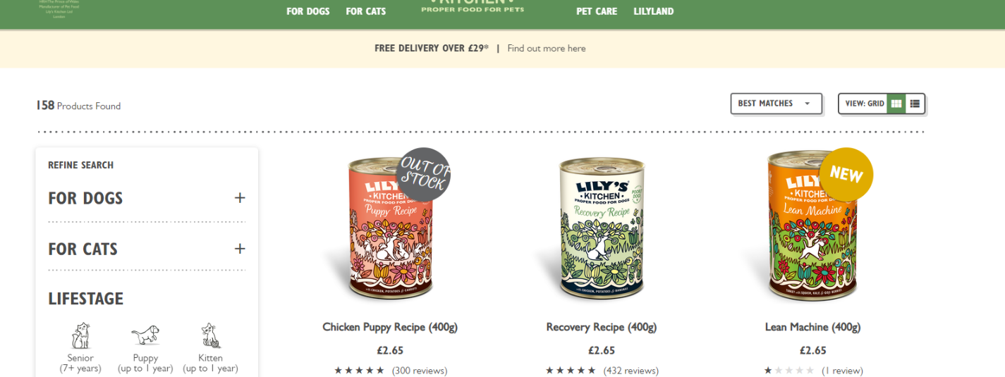

**URL:**

<https://www.lilyskitchen.co.uk/>

**Other:**

Noticed that searches that are invalid but return results, don’t have “Your search results for ****”

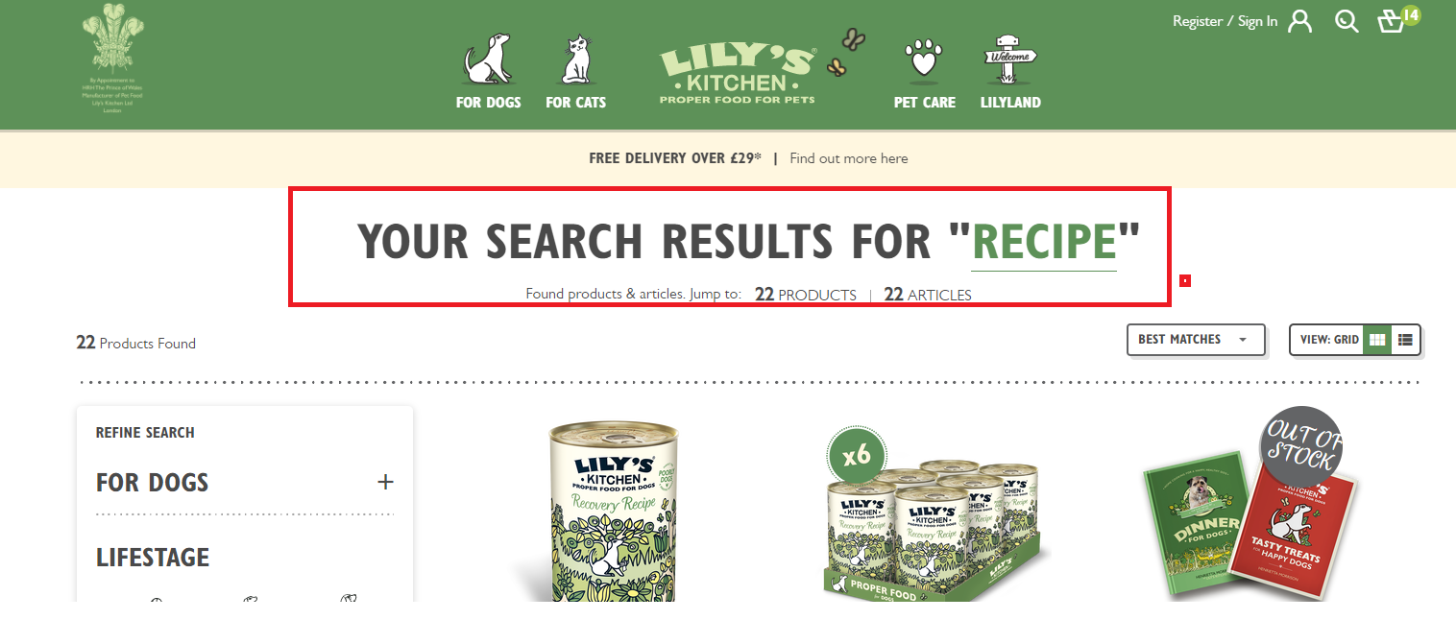

### **Bug 4.10:** Recommended Items from search vanish on window resize

**Severity:** Minor

**Environment:** <https://www.lilyskitchen.co.uk/>

**Browser:** Google Chrome (**Reproducible** on Mozilla Firefox)

**Device:** Desktop

**OS:** Windows 10

**Account:** Unregistered User

**Found by:** … and …

**Testing Methodology:** Pair-based Exploratory Testing; Navigator & Operator

**Date:** 27.06.21

**Steps to reproduce:**

1. Open the websitehttps://www.lilyskitchen.co.uk/
2. Open the search options
3. Enter the value “recipe”
4. Resize the window to a smaller scale
5. Verify the window
6. Maximize the window

**Expected result:** Resizing the window to a lower scale should keep the recommended items on display.

**Actual result:** As window form changes (new menu for features and navigation) recommended items are not visible. They become visible once window is maximized

**Screenshots / Logs:**



### **Bug 5.1:** Controversial options in the store locator leading to address mismatch

**Severity:** Minor

**Environment:** Reproducible on all environments

**Browser:** Reproducible on all browsers

**Device:** Mobile (Samsung A51)

**OS:** Android

**Account:** Unregistered User

**Found by:** …

**Methodology:** Exploratory testing

**Steps to reproduce:**

1. Open the website<https://www.lilyskitchen.co.uk/>
2. Click on the Find a stockiest category near the bottom of the page
3. Click on “Postcode/ Town” button
4. Write down 324(Grace Inn Road) as a Postcode.
5. Click on find stores.
6. Click on The De Beauvoir Deli Co. Ltd
7. Then click on View store details

**Expected result:** The expected address of the store is: 98 Southgate Road London N1 3SD

**Actual result:** When you open the map you can't find 98 Southgate Road. It is a wrong pinned address.

**Screenshots / Logs:**

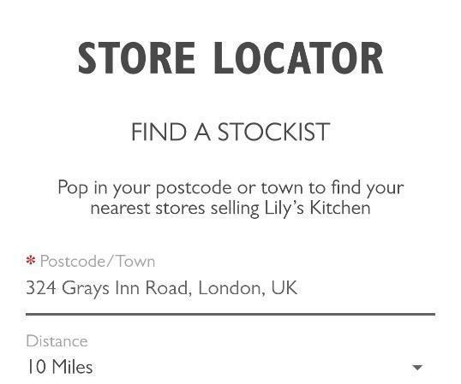

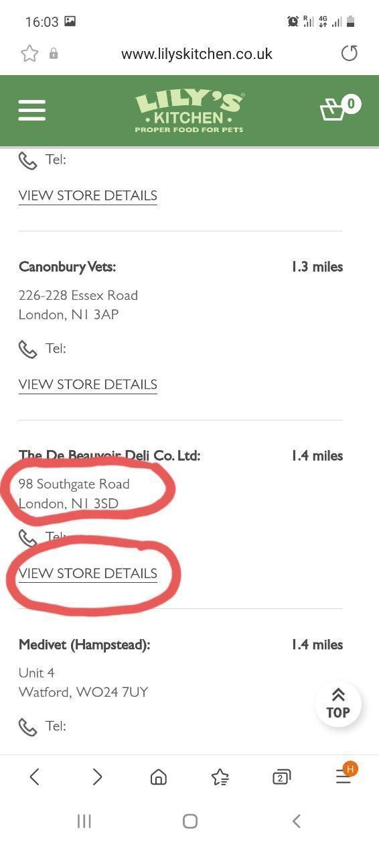

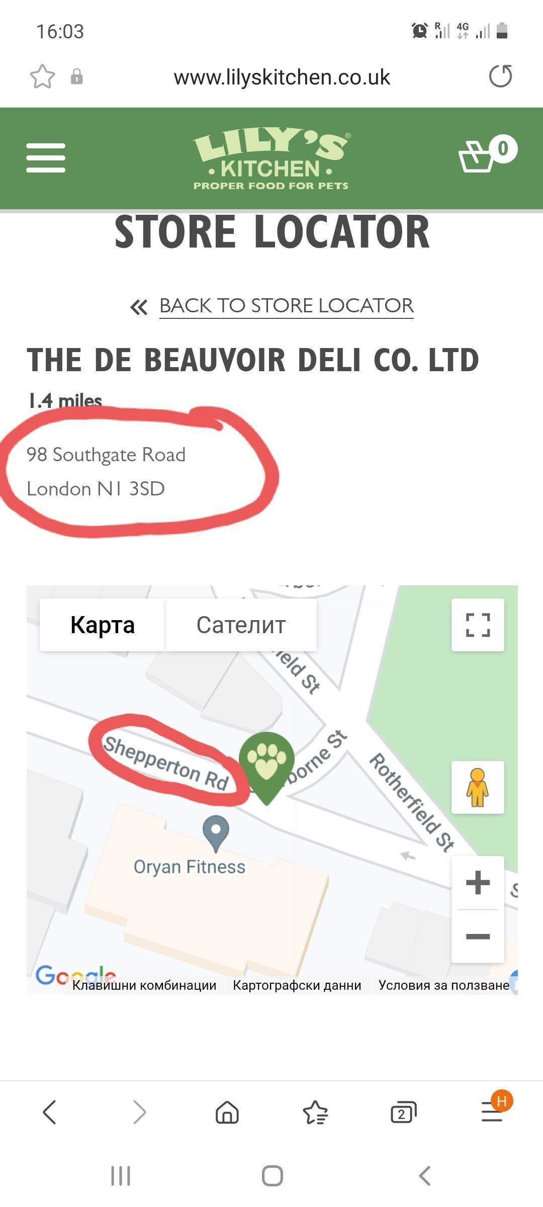

**URL:** <https://www.lilyskitchen.co.uk/stores/?StoreID=The%20De%20Beauvoir%20Deli%20Co.%20Ltd&distance=1.4>